Contents

Introduction 3

Azure AD Overview 4

Microsoft Graph 7

Graph Explorer portal: 8

Design authentication 8

Azure AD Domain Services 9

Azure AD Roles 9

Azure AD Connect 10

Topologies for Azure AD Connect 10

Authentication Options 10

Cloud only Authentication 11

Hybrid Authentication 11

Choosing Authentication 15

Passwordless Authentication Option 16

SSO 16

Same Sign On 17

Seamless Sign On 17

Single Sign On 17

Azure B2B 18

Azure B2C 18

Security 19

Conditional Access 19

Identity Protection 21

Security Centre 22

Application Proxy for Remote Authentication 22

Design authorization 23

AD Groups 24

Group Types 24

Membership Type 25

My Account 26

My Apps 27

My Work Account 27

Password Reset 27

SSPR 28

Combined SSPR & MFA 29

Stop Weak passwords 29

MFA 30

Entitle Management 33

Design governance 33

Governance Aspects 34

Resource Structure 34

RBAC 35

Naming Standards & Tagging 35

Templates 35

Policy 35

Cost Management 37

Design security for applications 37

Azure AD MASL 37

# Introduction

<https://social.technet.microsoft.com/wiki/contents/articles/15530.the-four-pillars-of-identity-identity-management-in-the-age-of-hybrid-it.aspx>

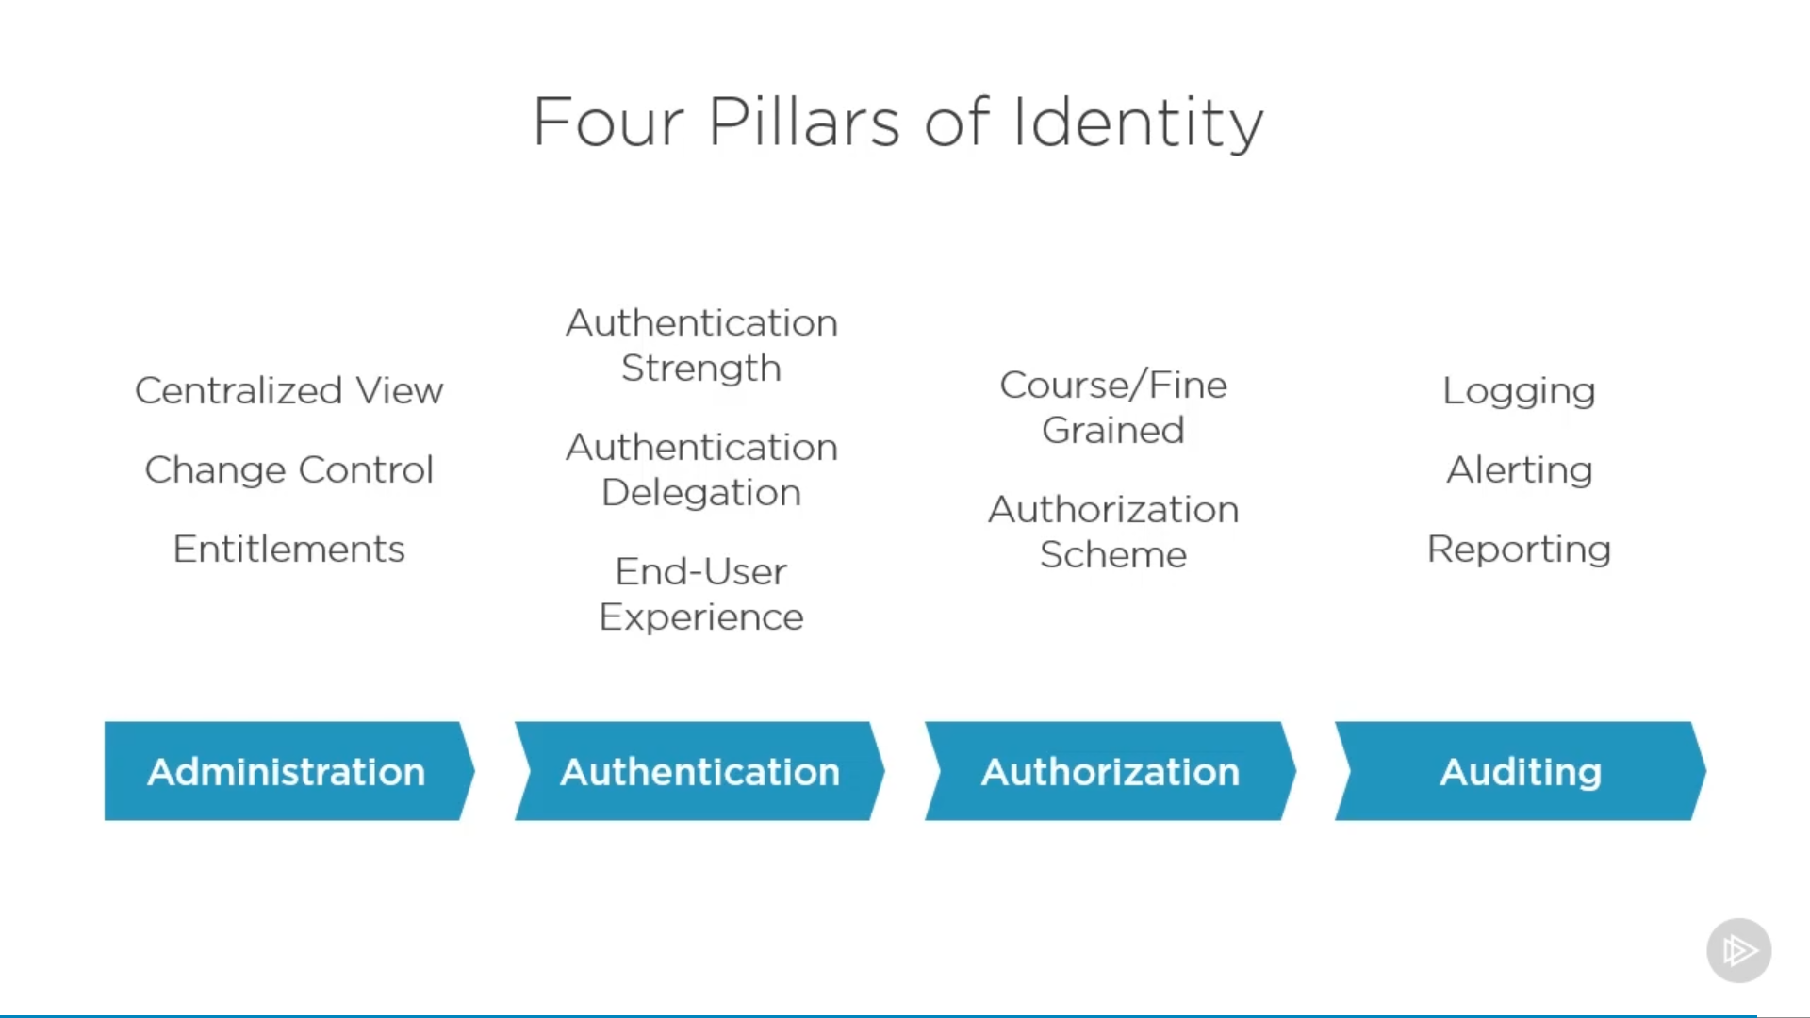

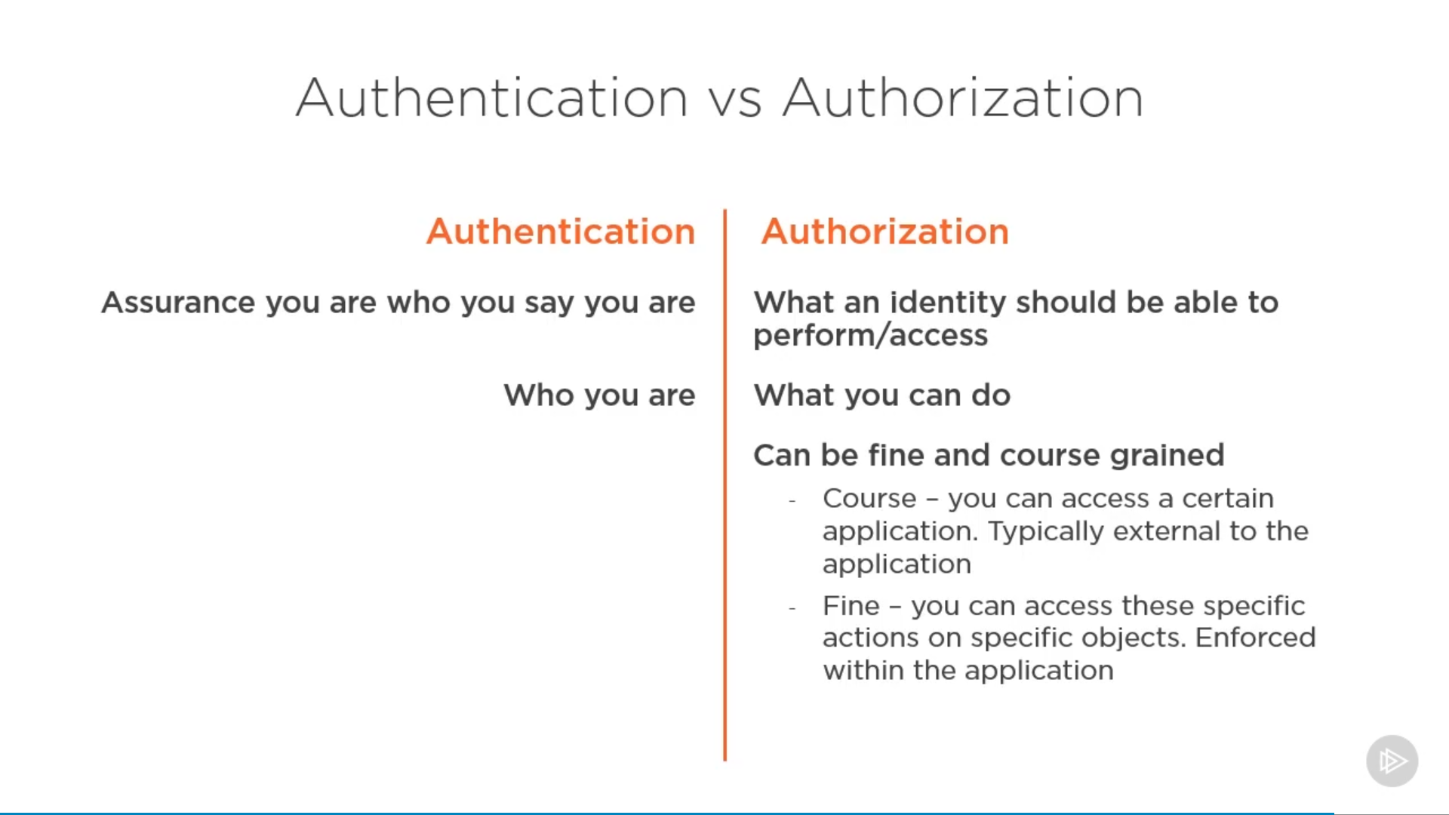

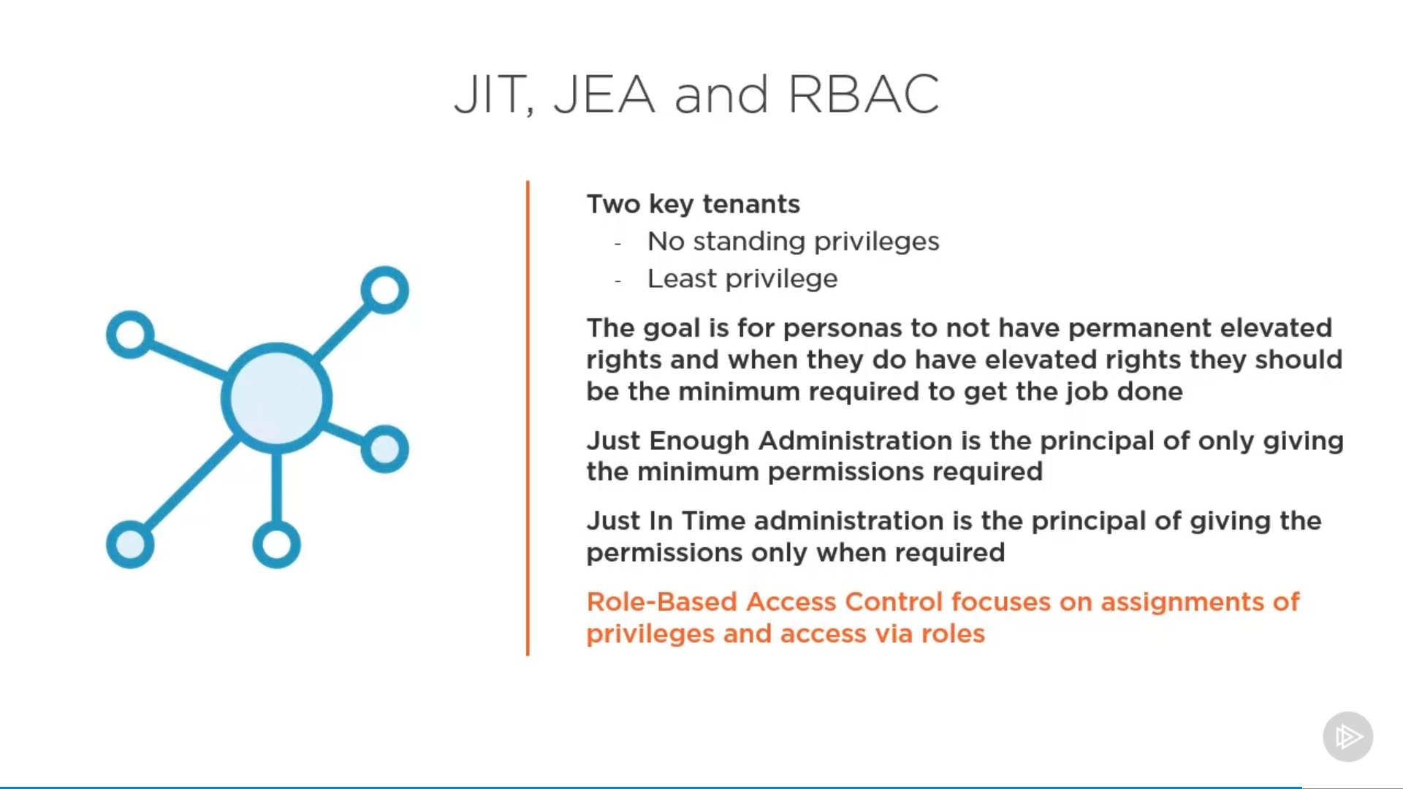

# Azure AD Overview

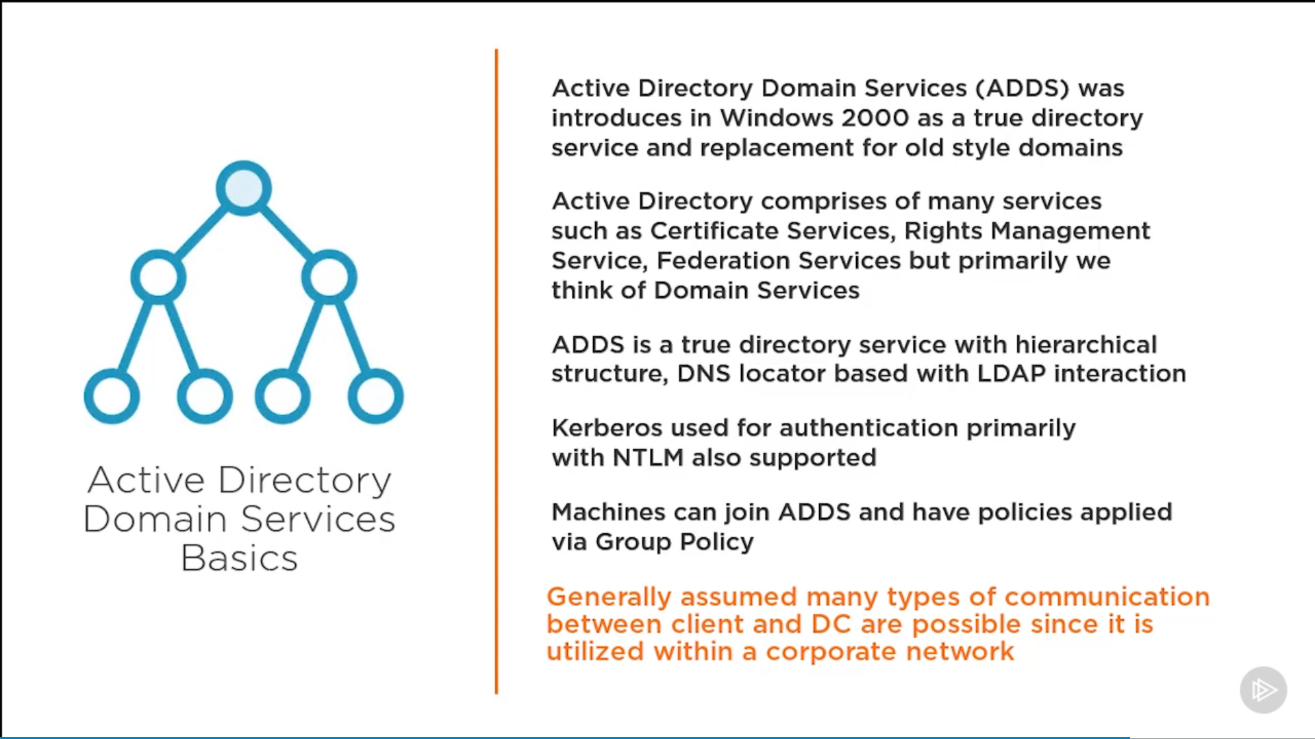

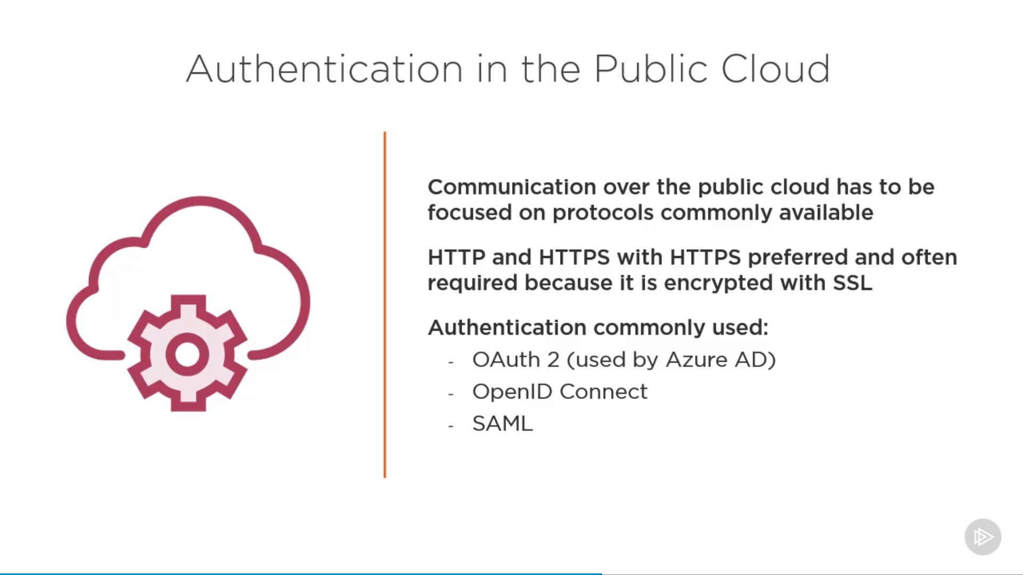

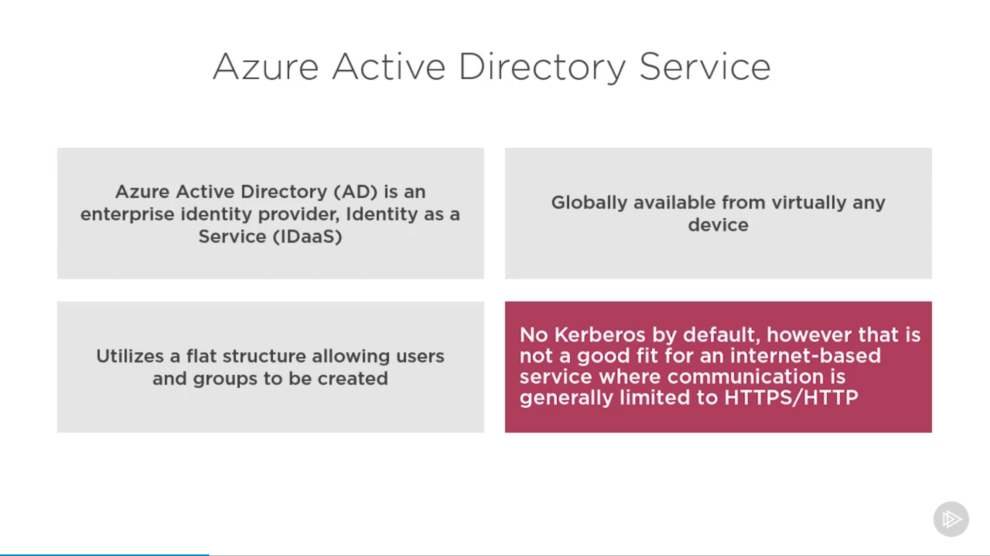

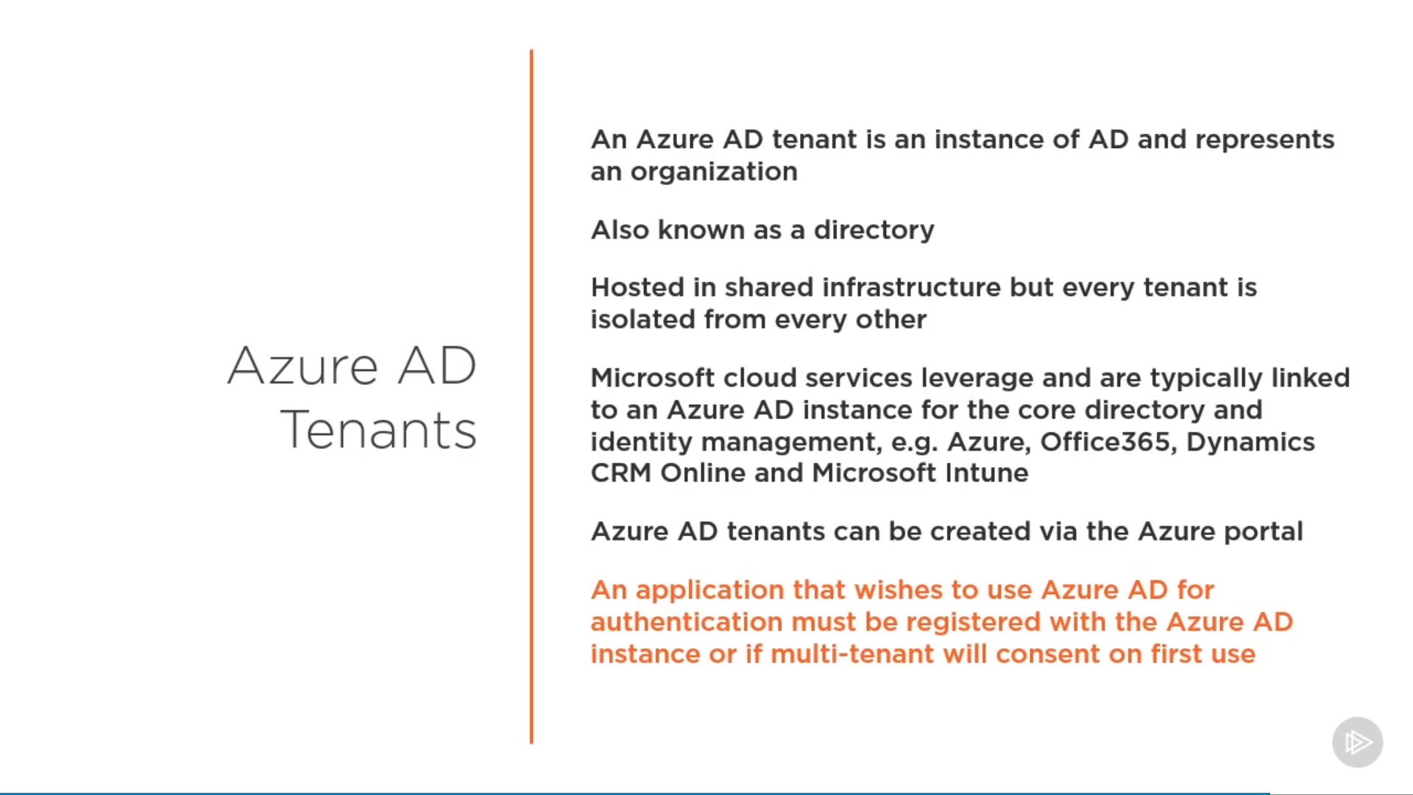

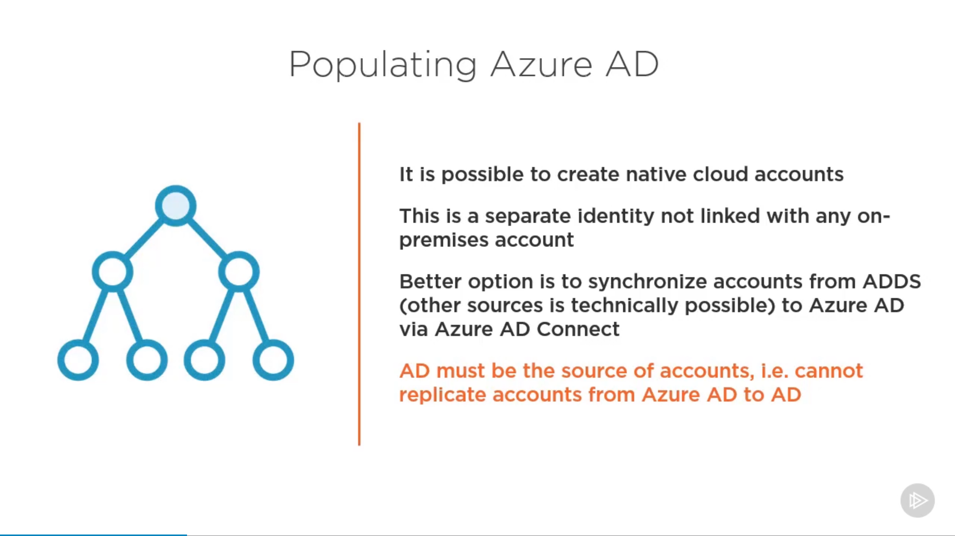

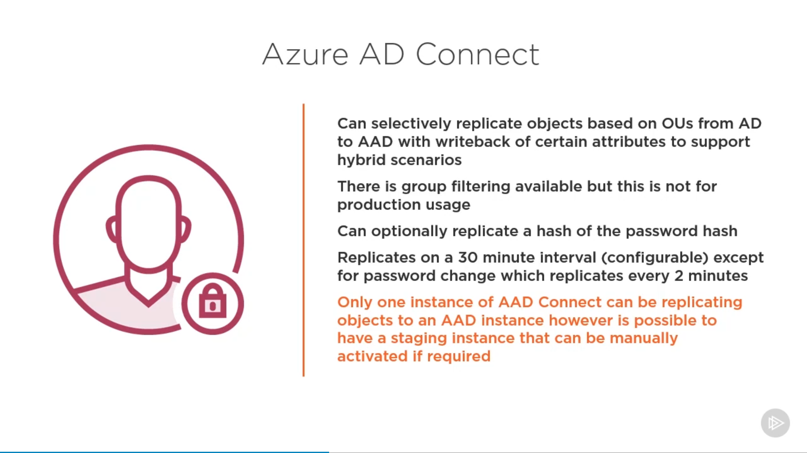

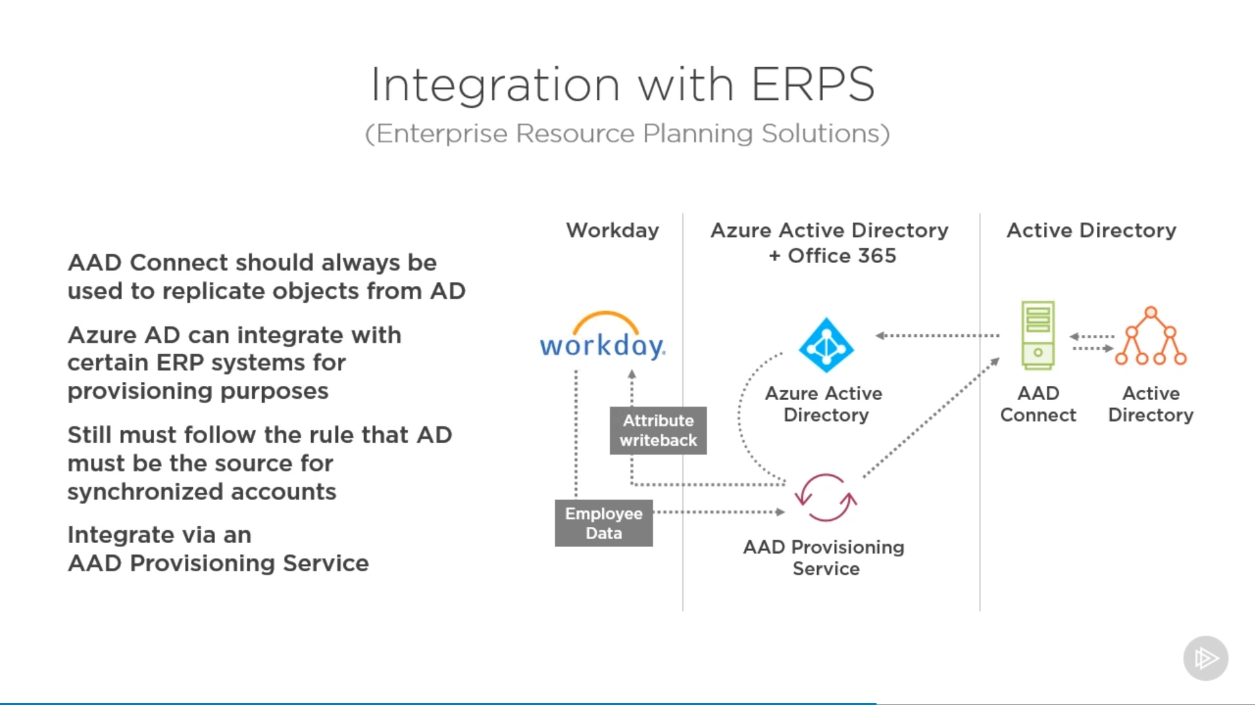

## Microsoft Graph

<https://docs.microsoft.com/en-us/graph/overview>

Microsoft Graph exposes REST APIs and client libraries to access data on the following Microsoft cloud services:

* Microsoft 365 services: Delve, Excel, Microsoft Bookings, Microsoft Teams, OneDrive, OneNote, Outlook/Exchange, Planner, SharePoint, Workplace Analytics.
* Enterprise Mobility and Security services: Advanced Threat Analytics, Advanced Threat Protection, Azure Active Directory, Identity Manager, and Intune.
* Windows 10 services: activities, devices, notifications, Universal Print (preview).
* Dynamics 365 Business Central.

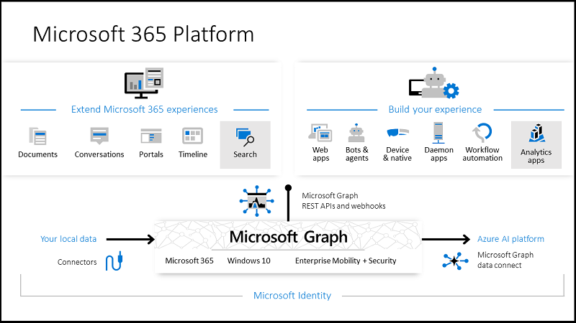

### Graph Explorer portal:

<https://developer.microsoft.com/en-us/graph/graph-explorer>

# Design authentication

* recommend a solution for single-sign on
* recommend a solution for authentication
* recommend a solution for Conditional Access, including multi-factor authentication
* recommend a solution for network access authentication
* recommend a solution for a hybrid identity including Azure AD Connect and Azure AD Connect Health
* recommend a solution for user self-service
* recommend and implement a solution for B2B integration

**Azure AD playlist**:

<https://www.youtube.com/playlist?list=PL-V4YVm6AmwUFpC3rXr2i2piRQ708q_ia>

## Azure AD Domain Services

<https://docs.microsoft.com/en-us/azure/active-directory-domain-services/overview>

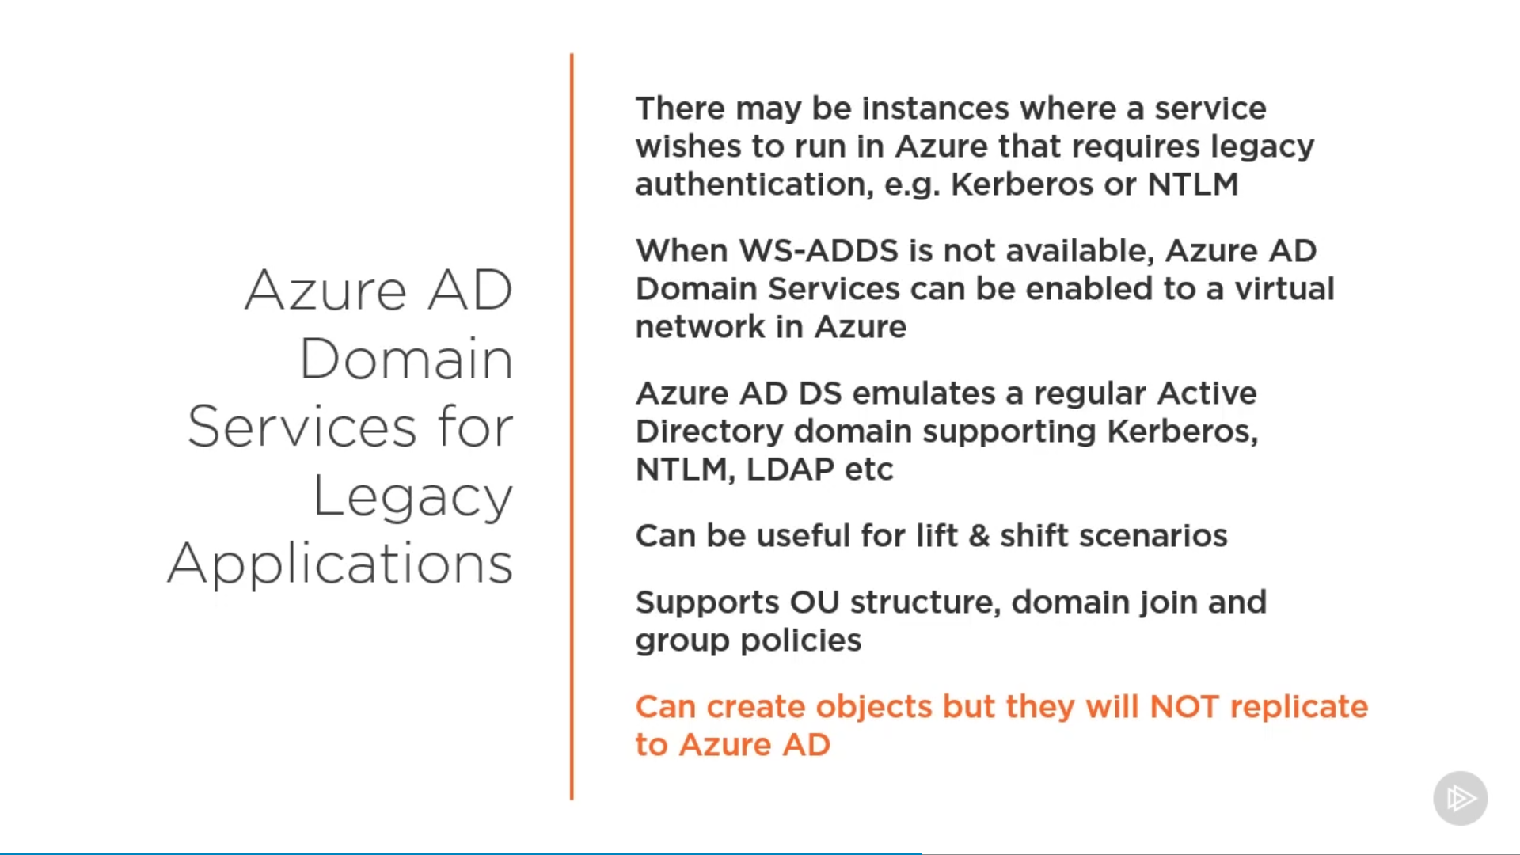

## Azure AD Roles

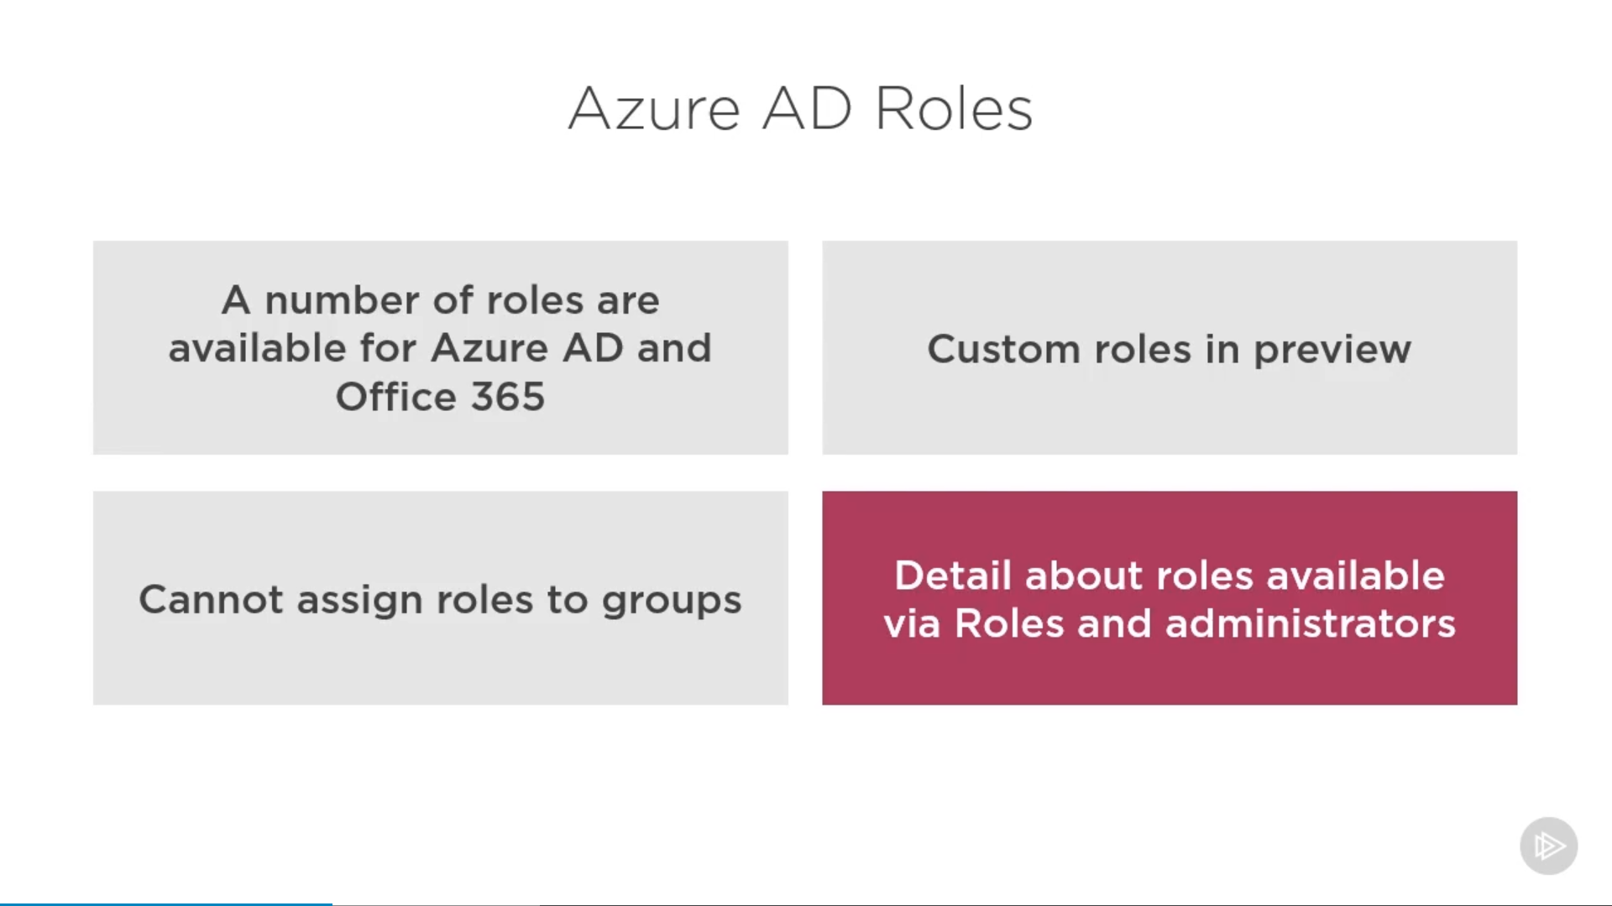

**Administrative units can be used to assign roles to a set of users.**

## Azure AD Connect

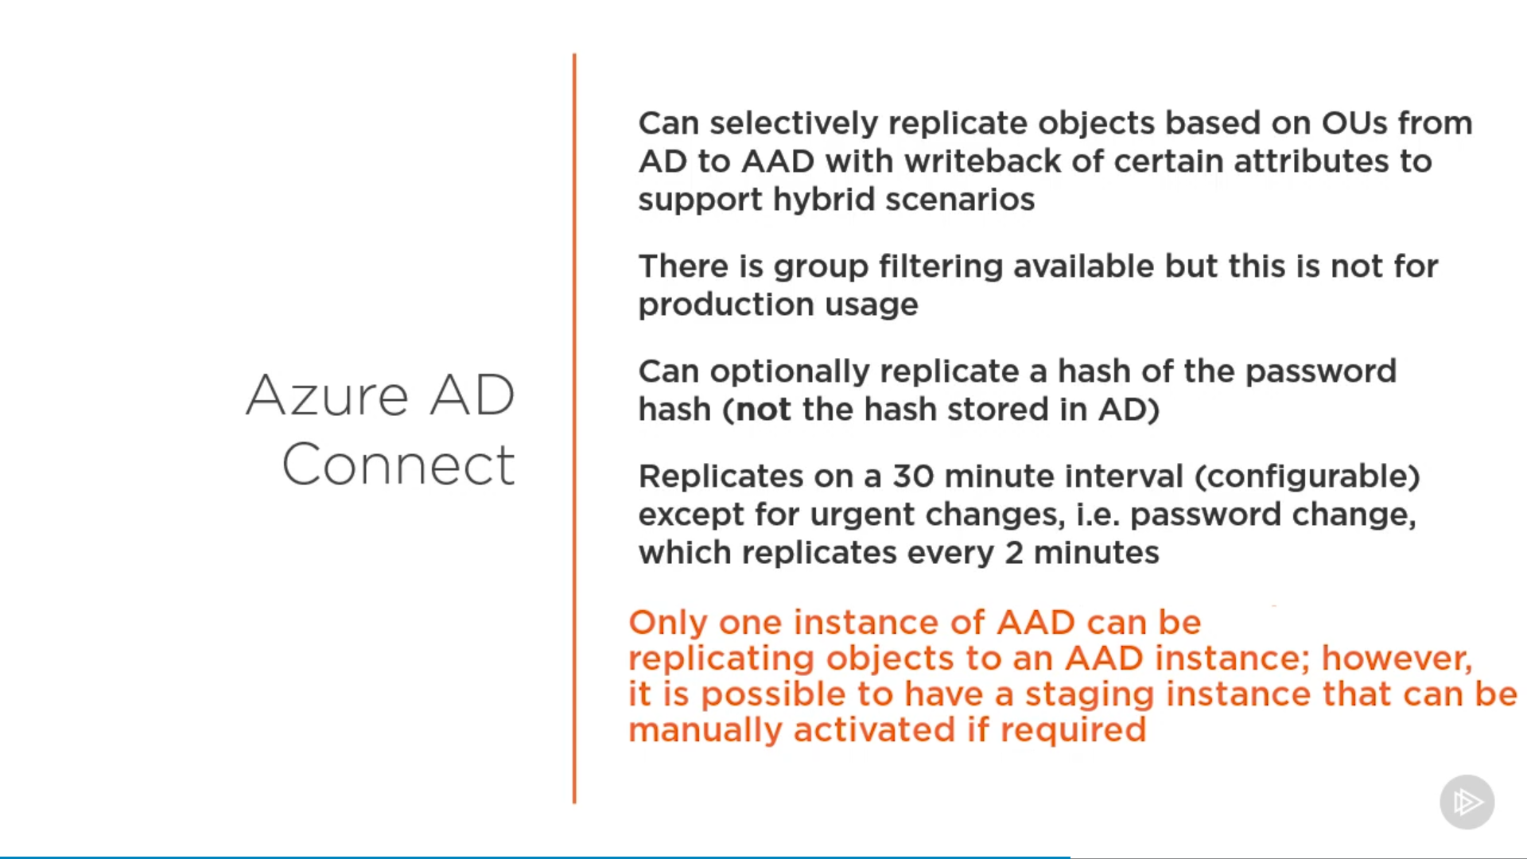

### Topologies for Azure AD Connect

<https://docs.microsoft.com/en-us/azure/active-directory/hybrid/plan-connect-topologies>

## Authentication Options

### Cloud only Authentication

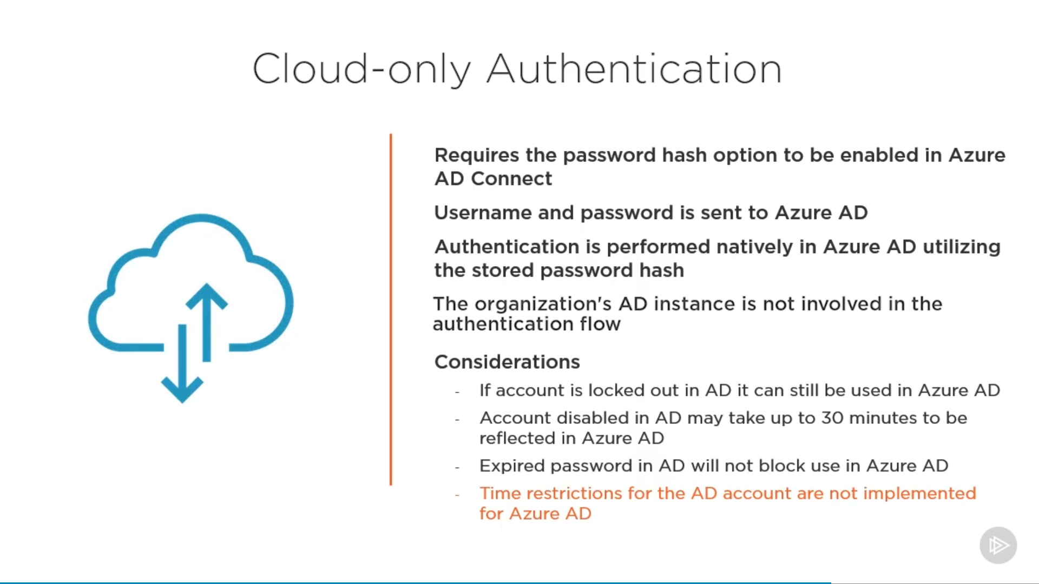

### Hybrid Authentication

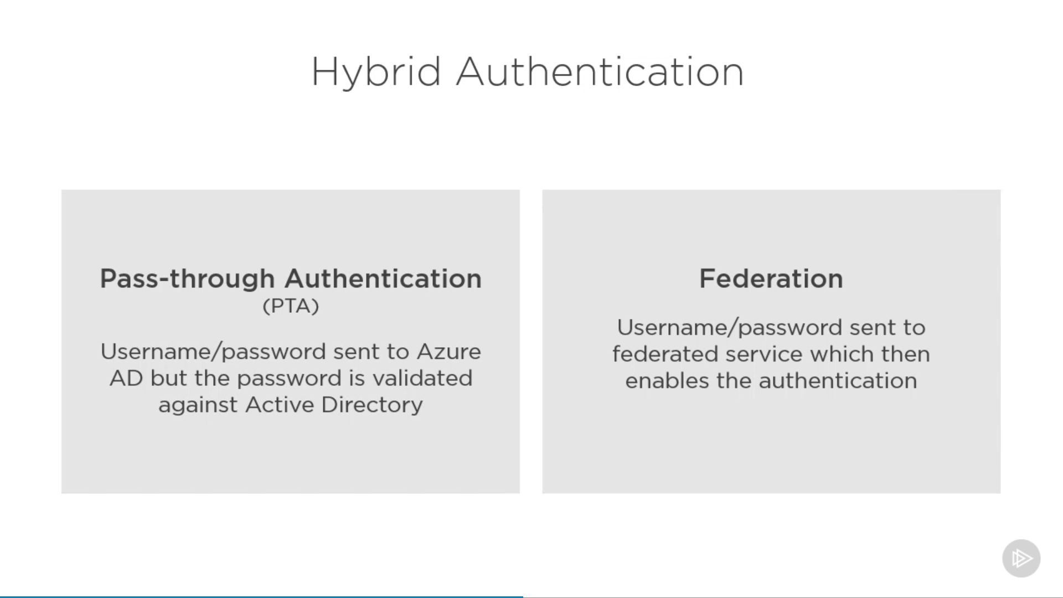

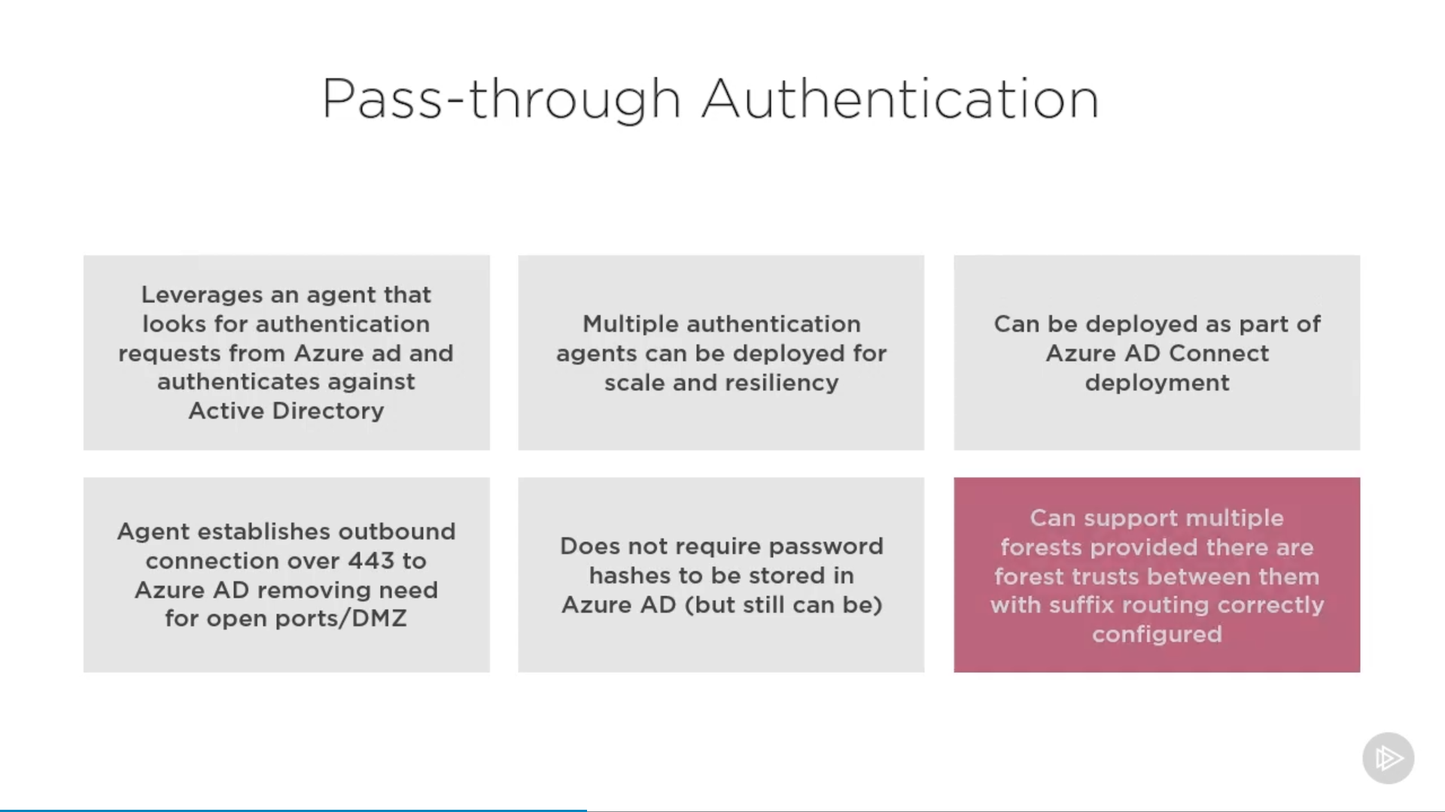

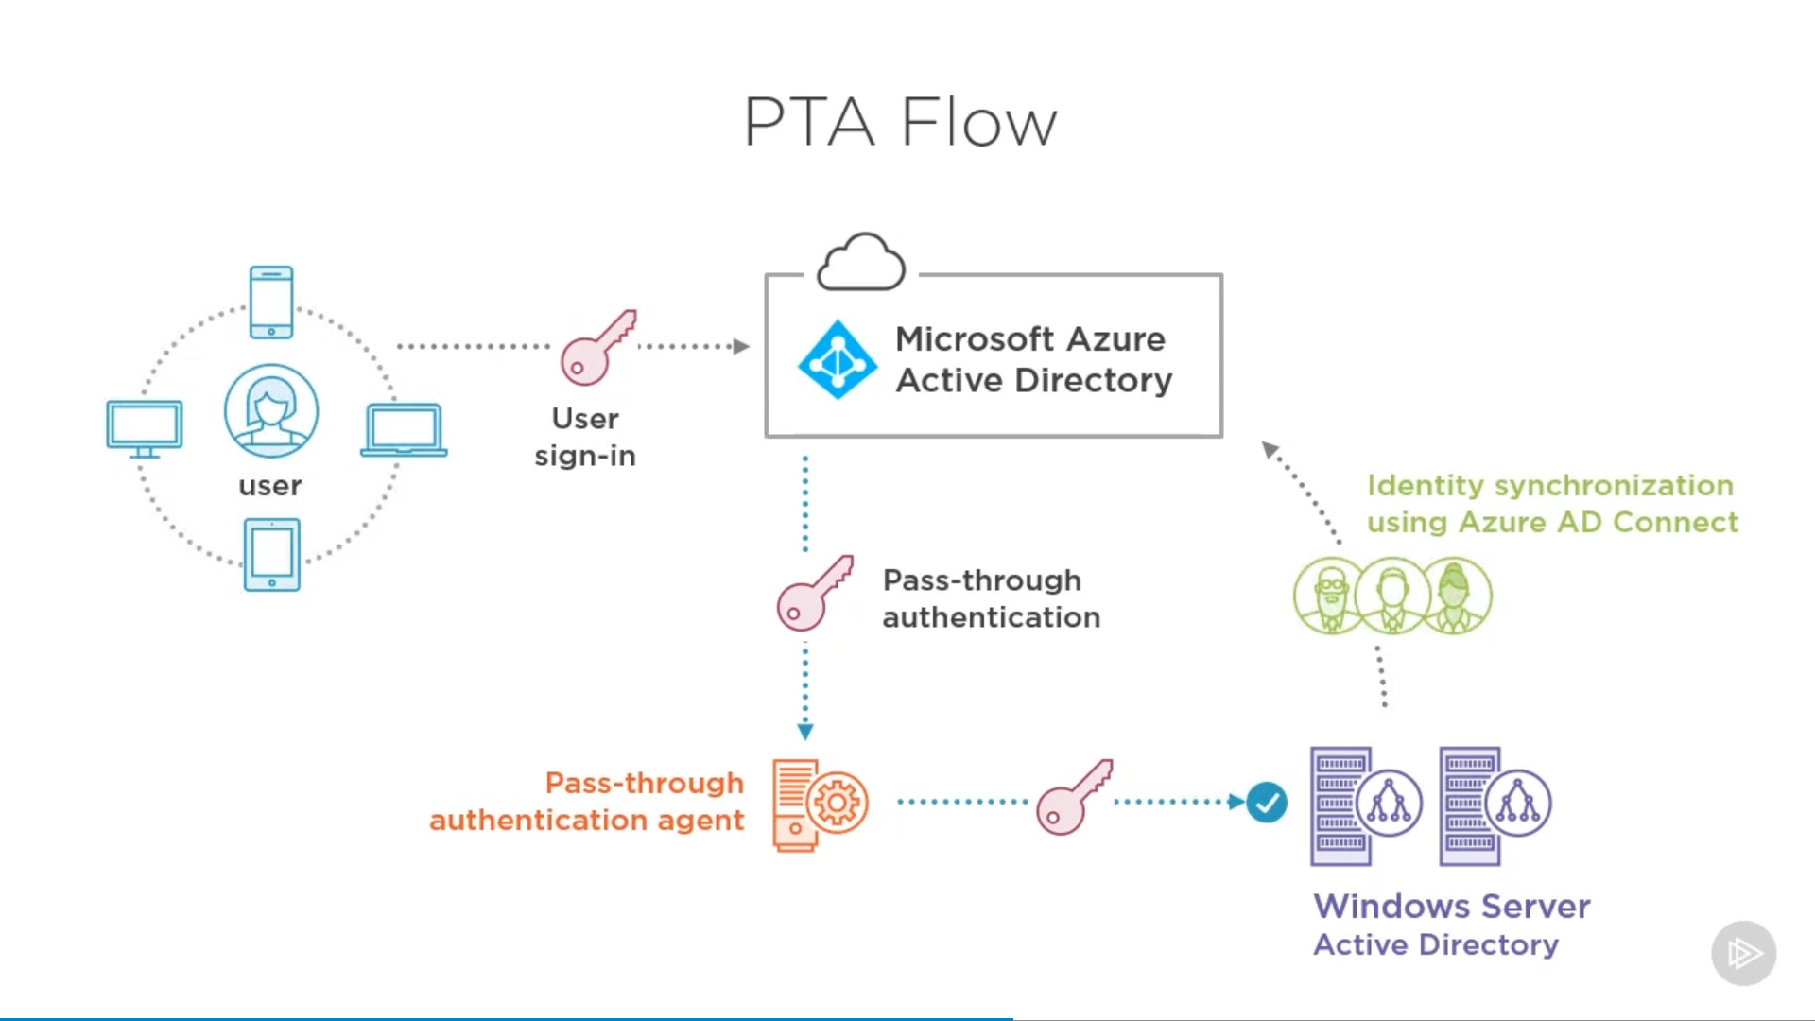

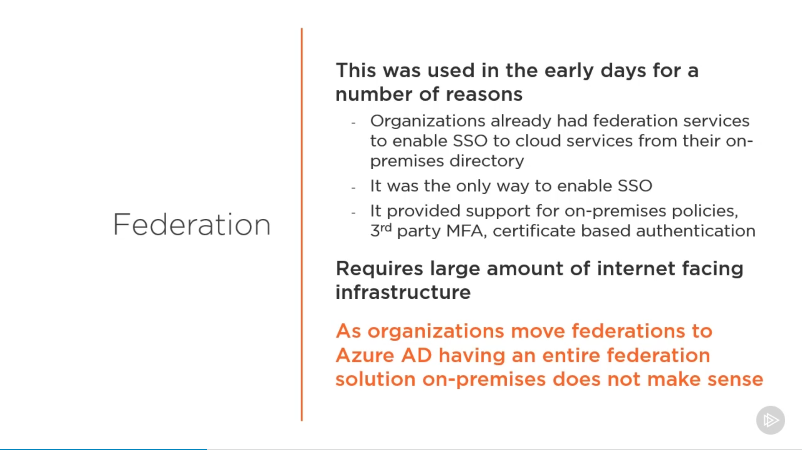

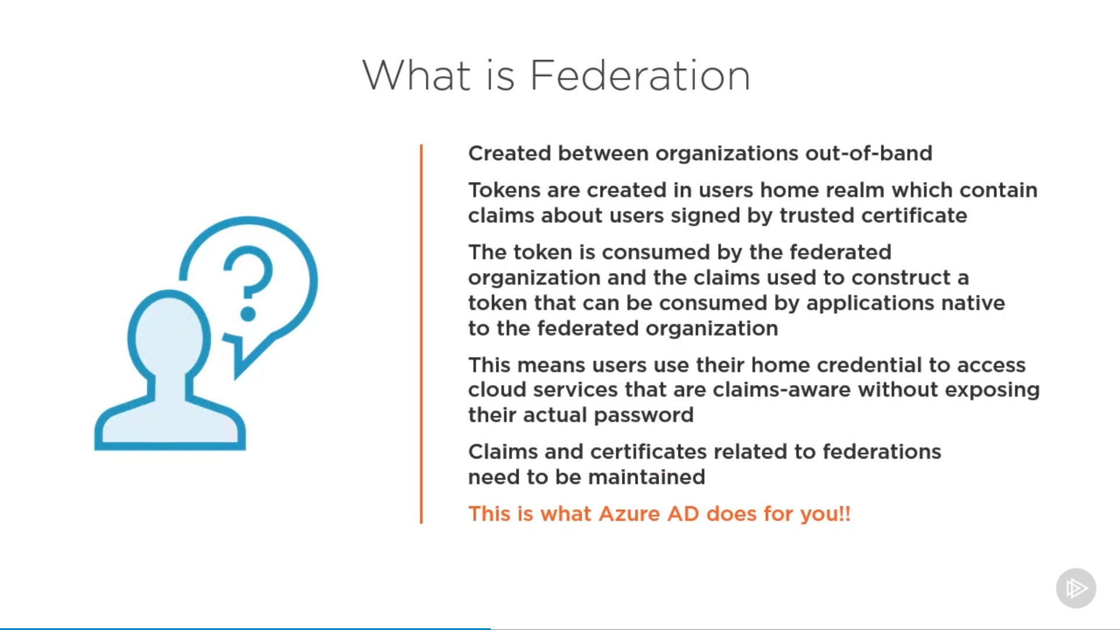

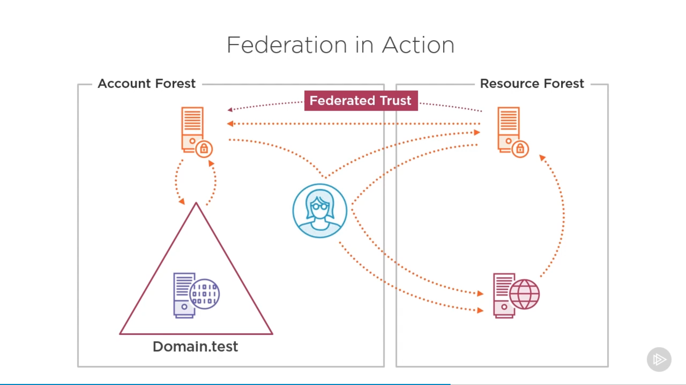

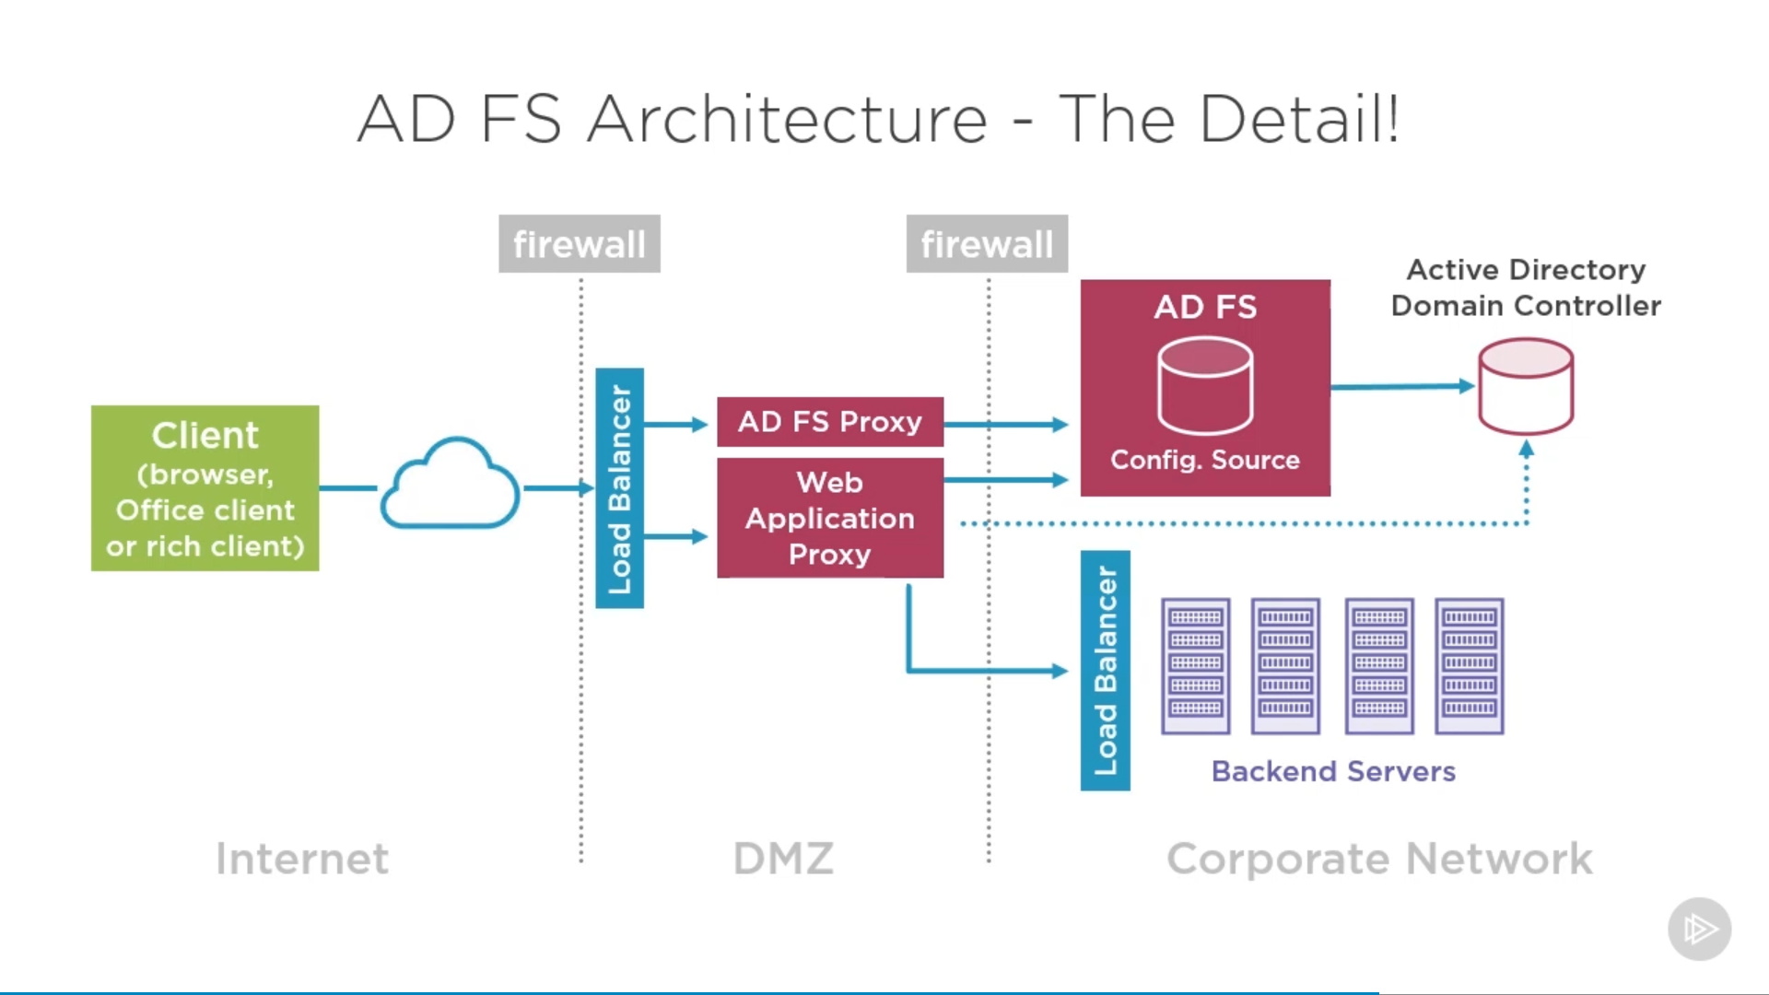

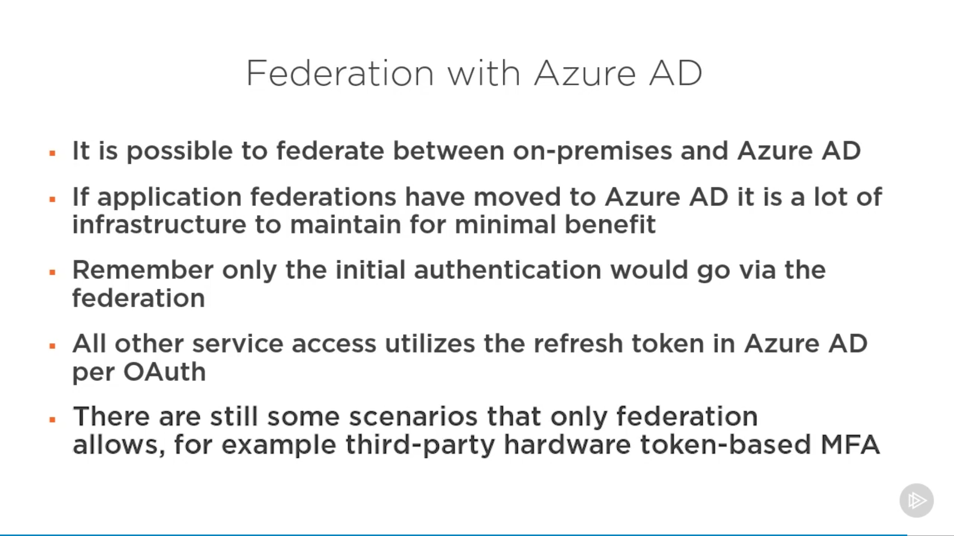

### Choosing Authentication

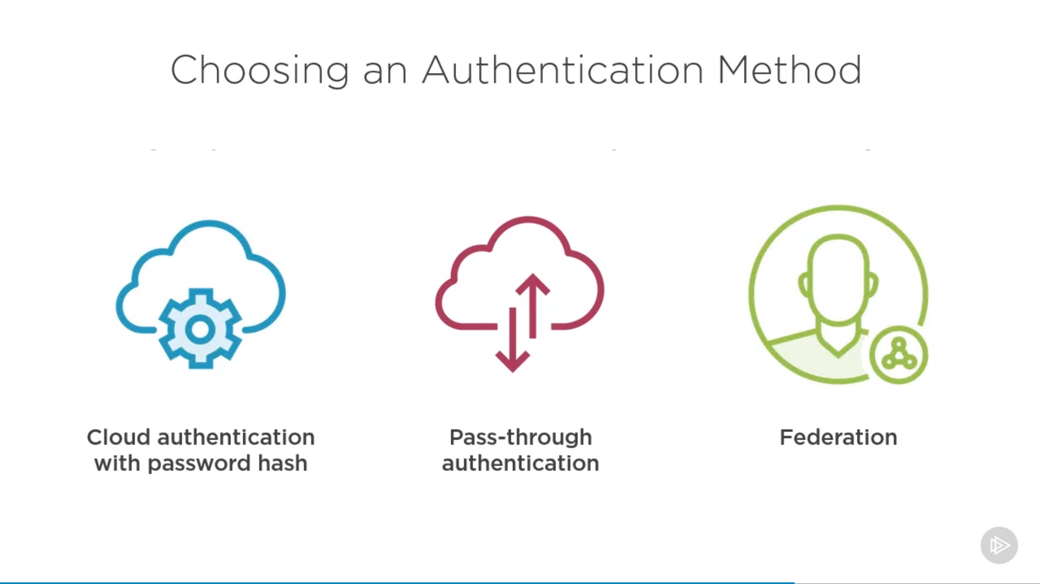

<https://docs.microsoft.com/en-us/azure/active-directory/hybrid/choose-ad-authn>

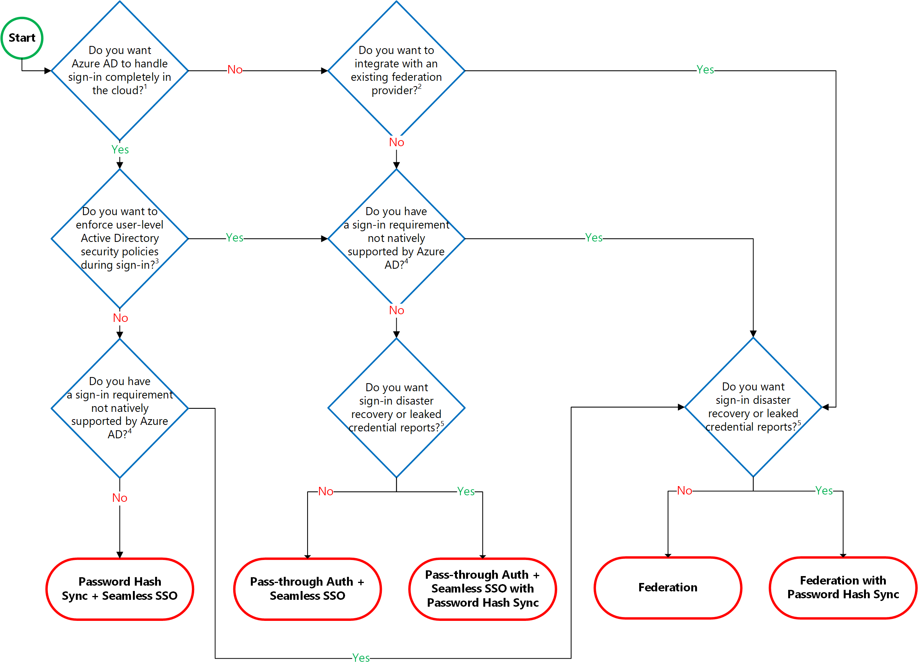

### Passwordless Authentication Option

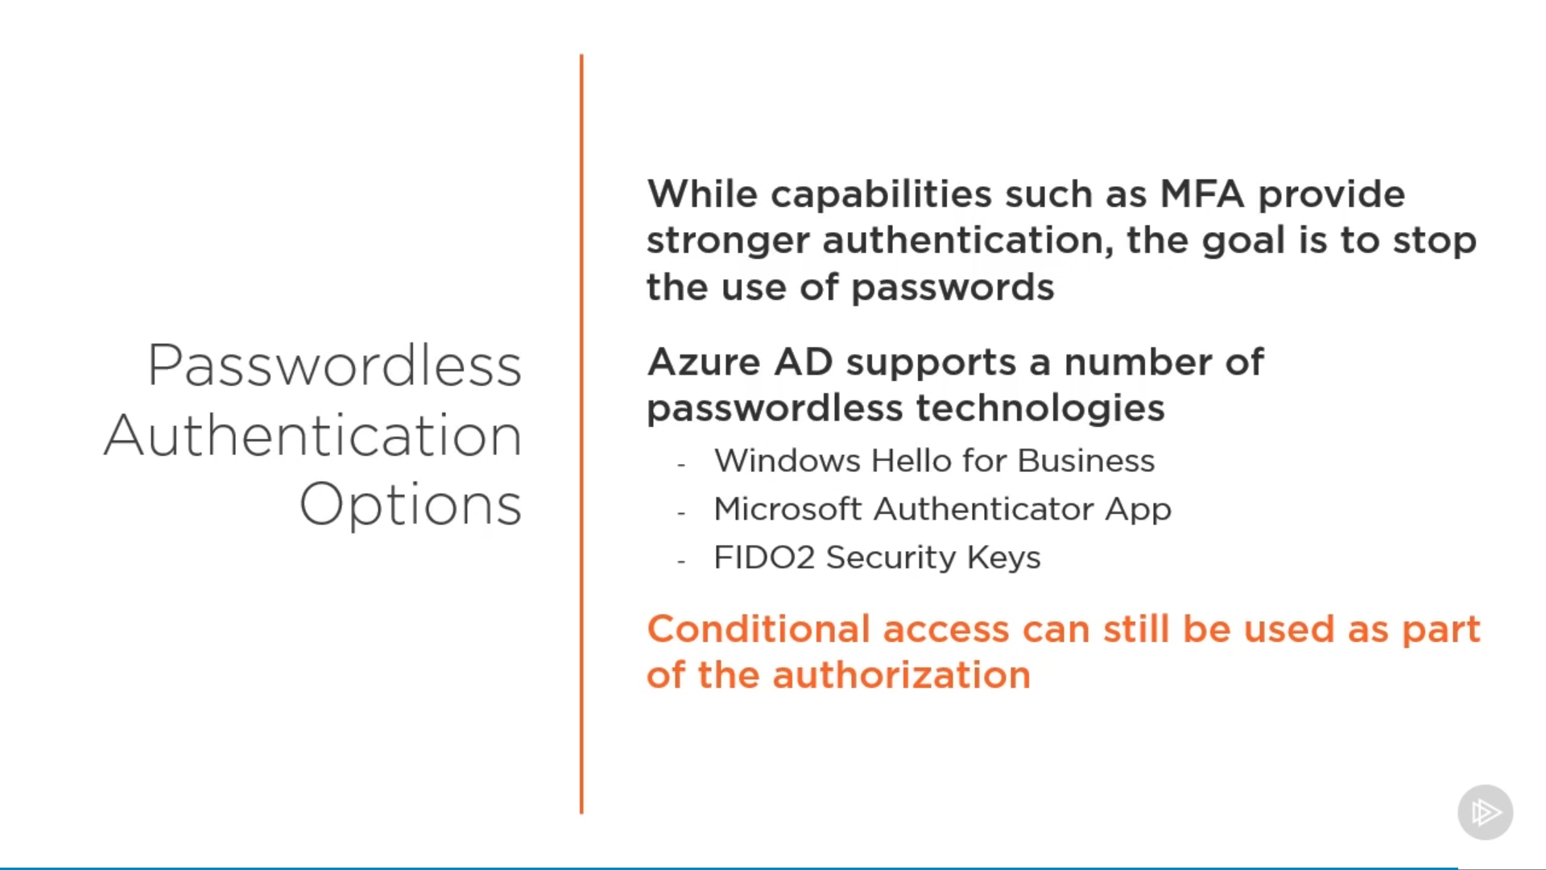

## SSO

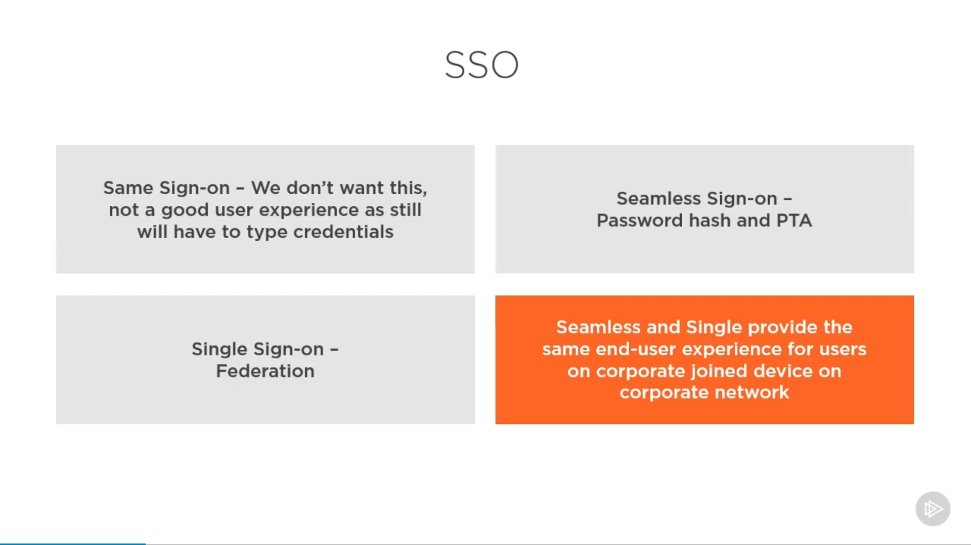

### Same Sign On

### Seamless Sign On

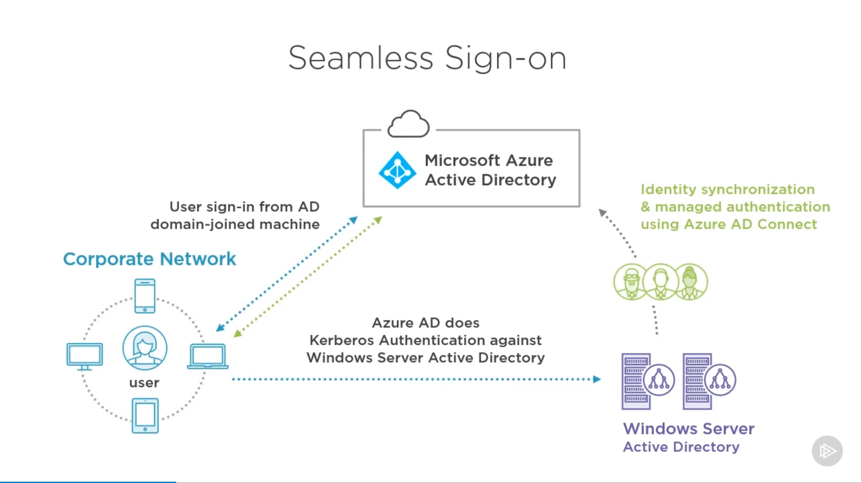

### Single Sign On

## Azure B2B

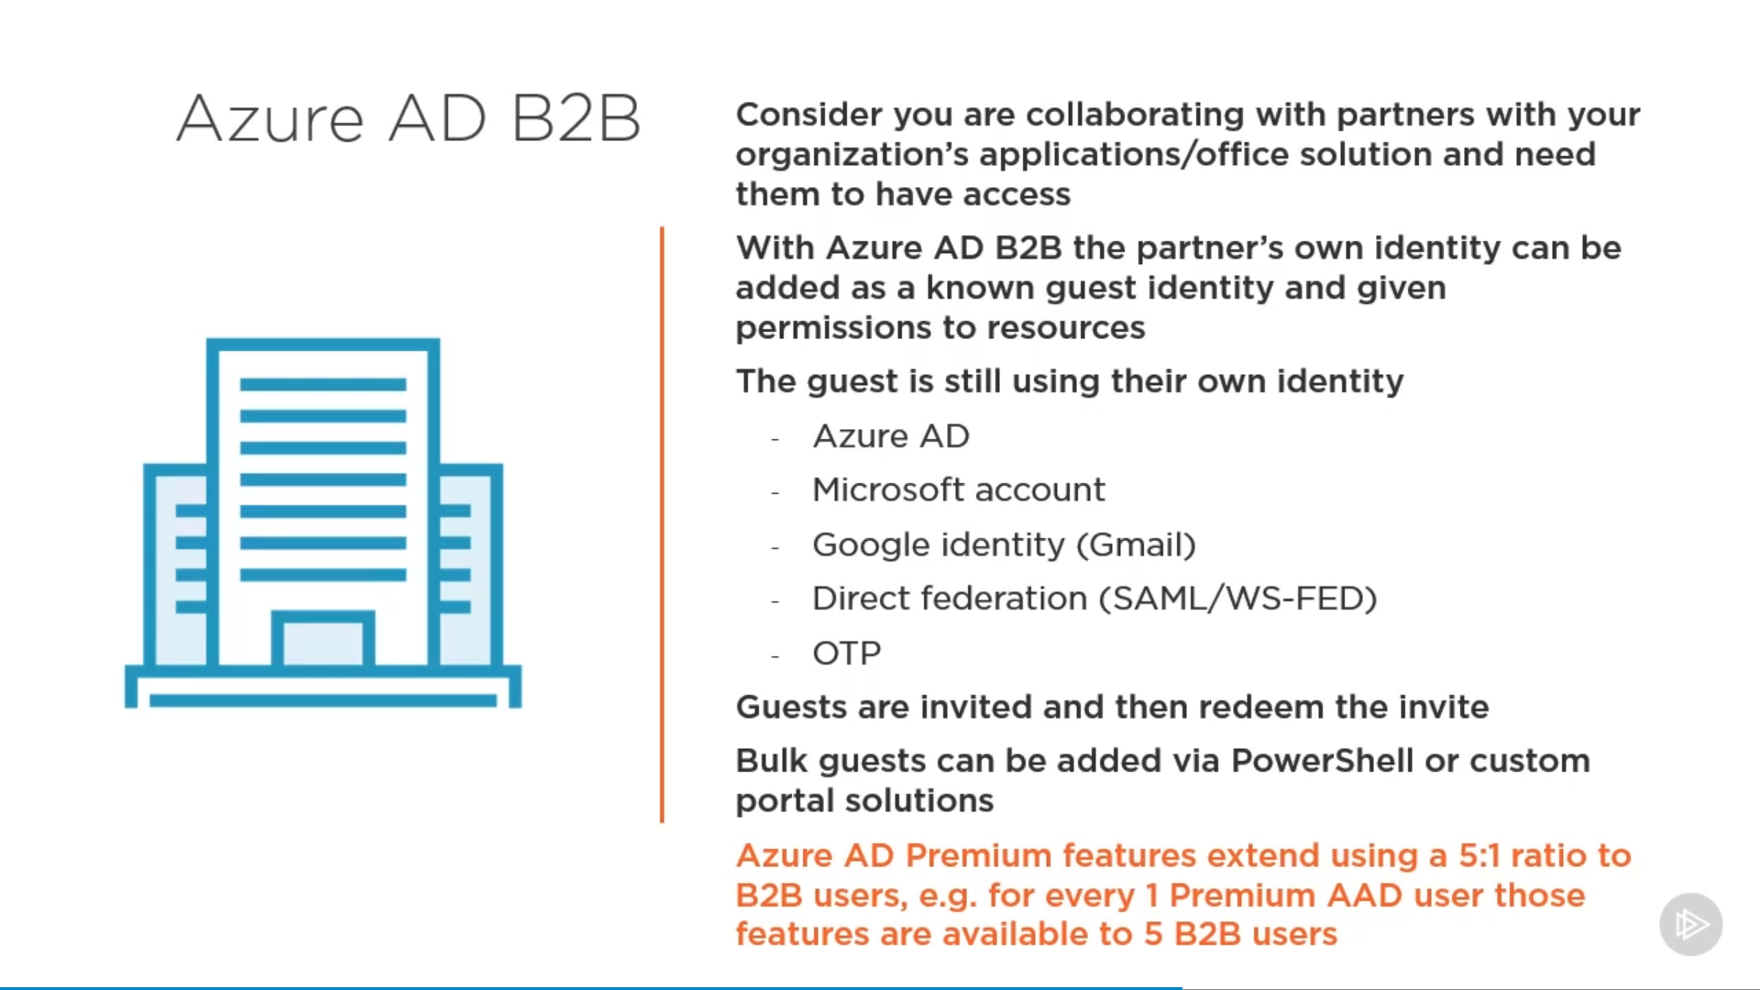

## Azure B2C

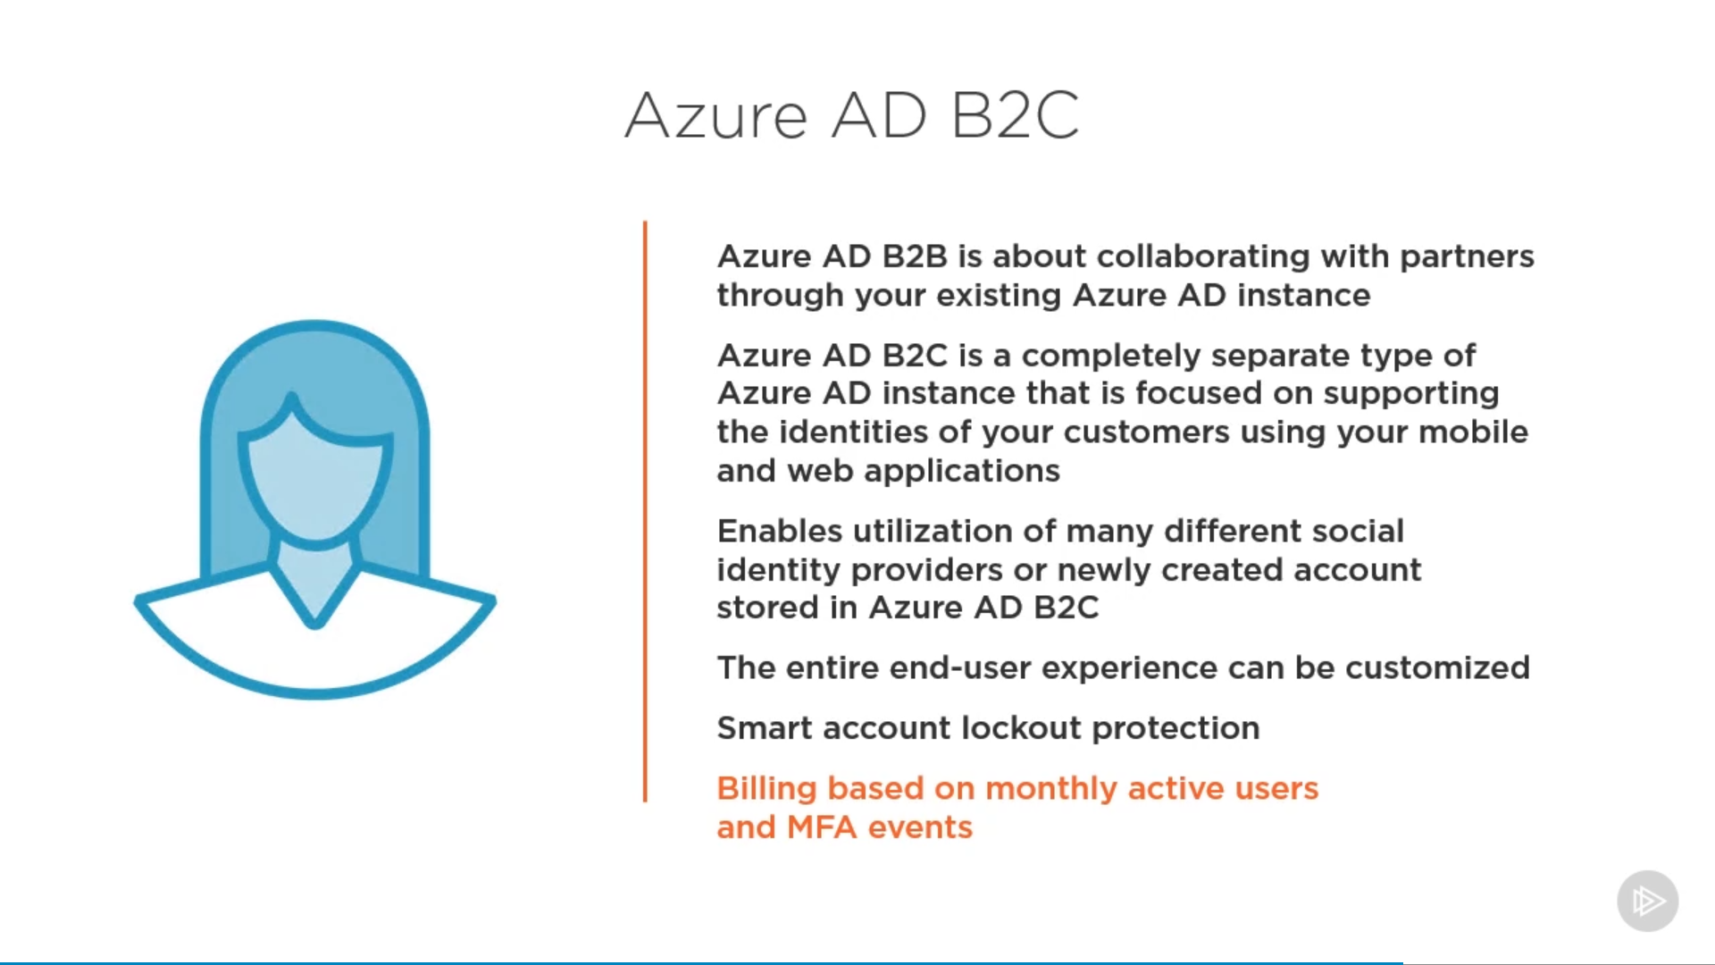

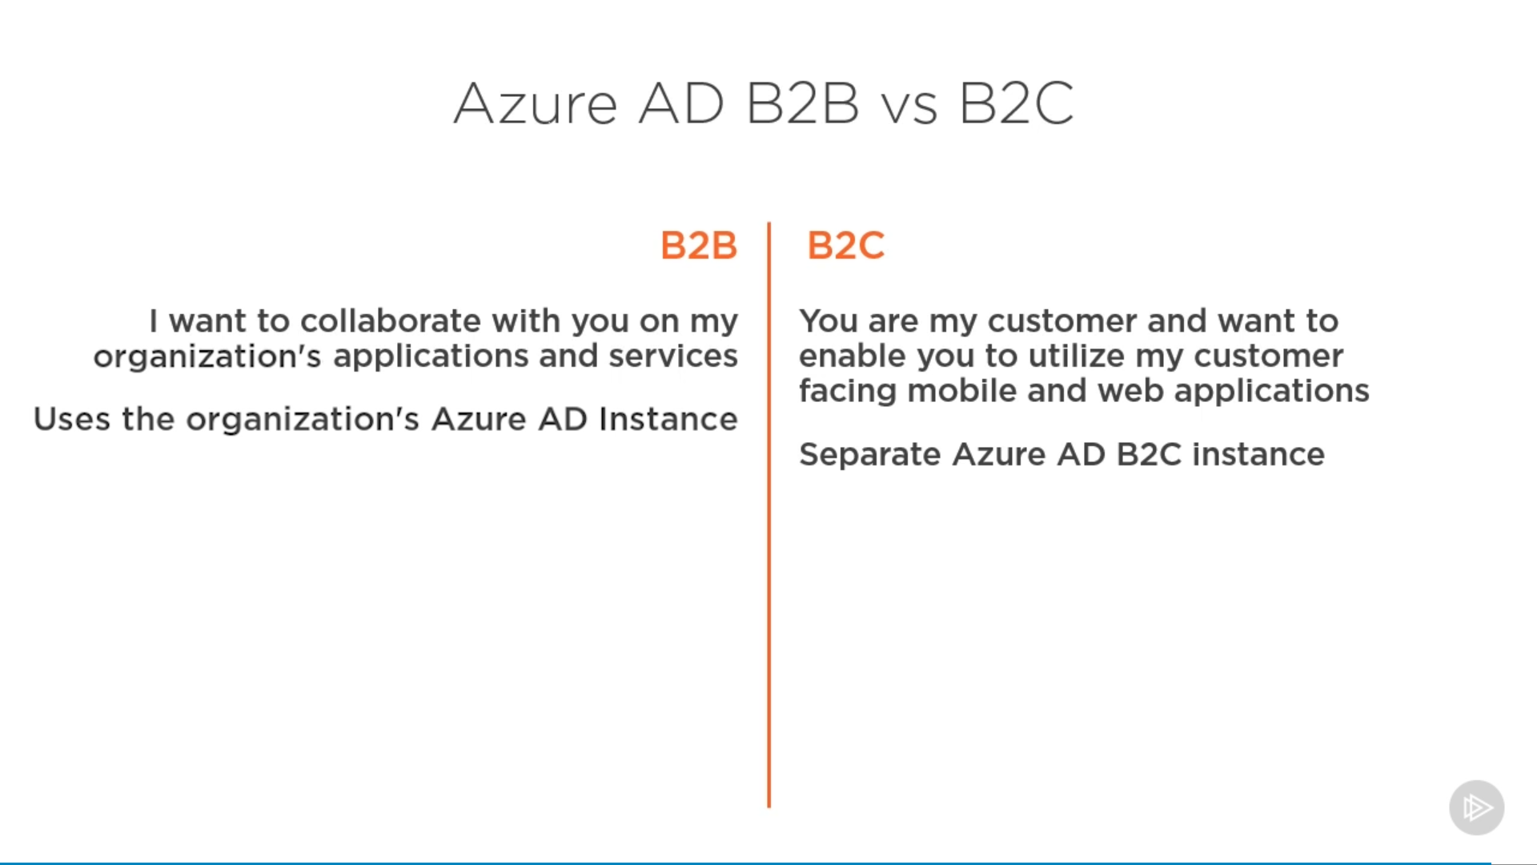

## Security

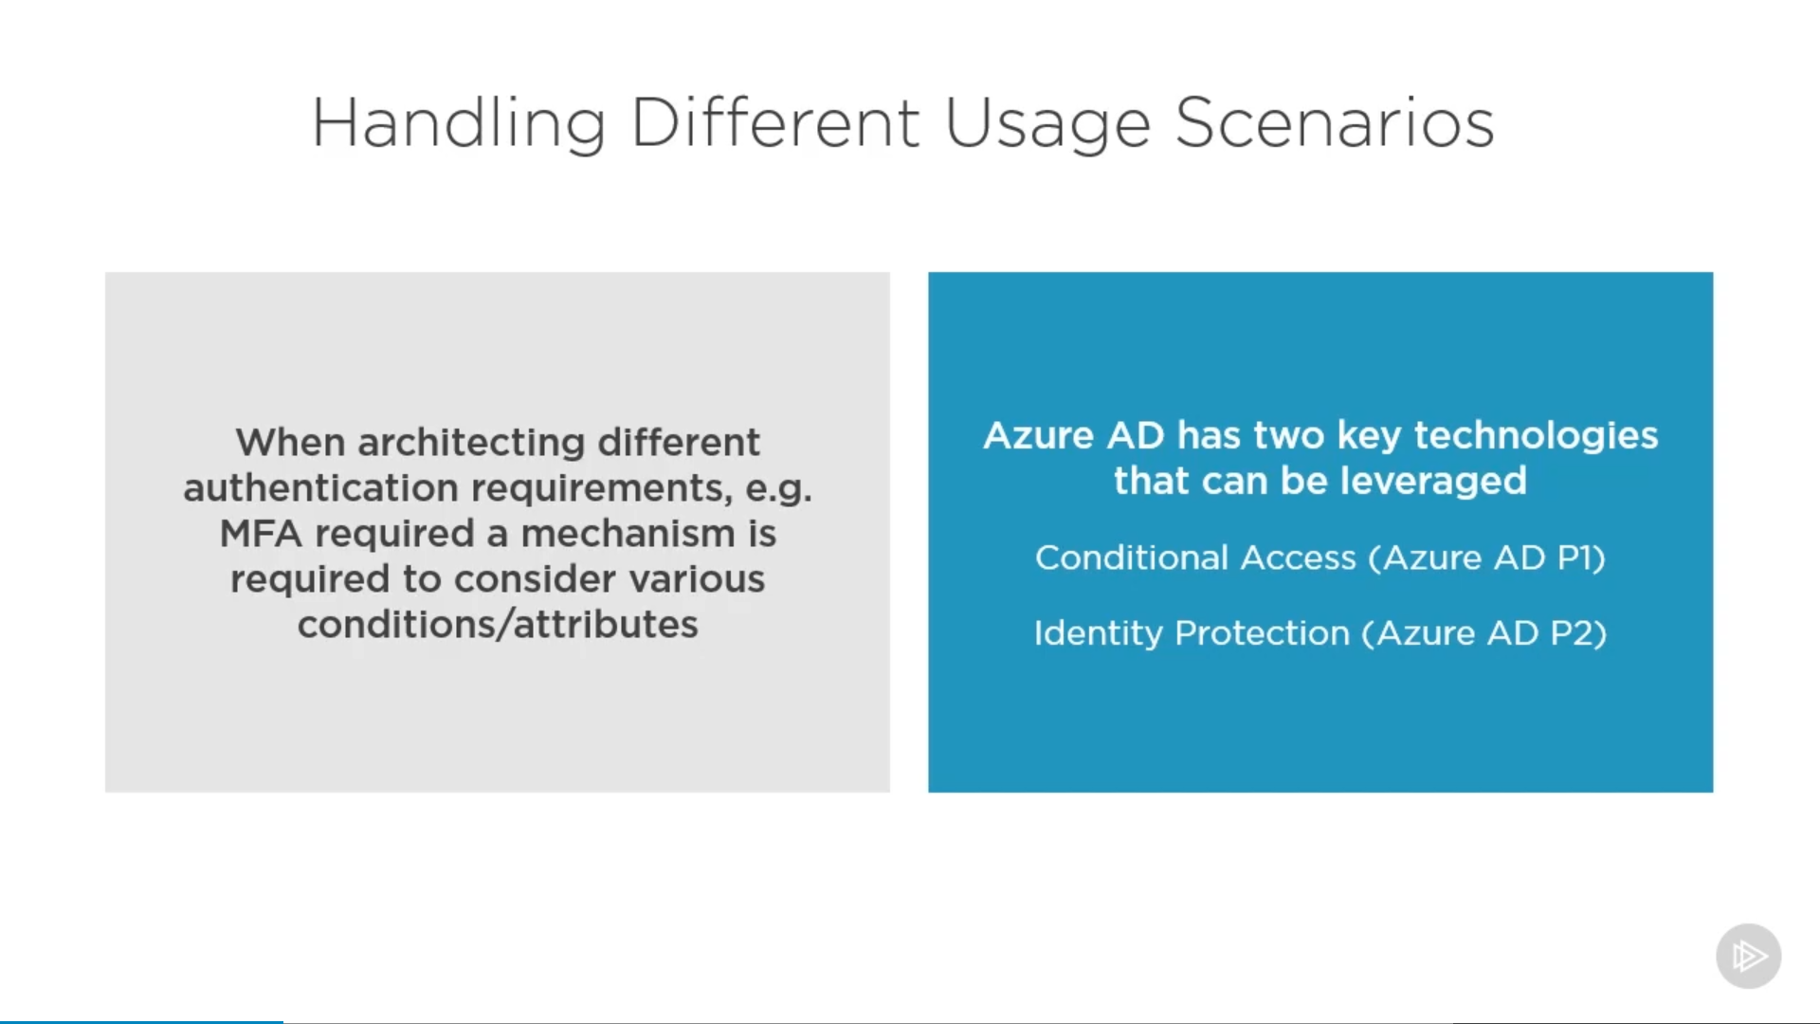

### Conditional Access

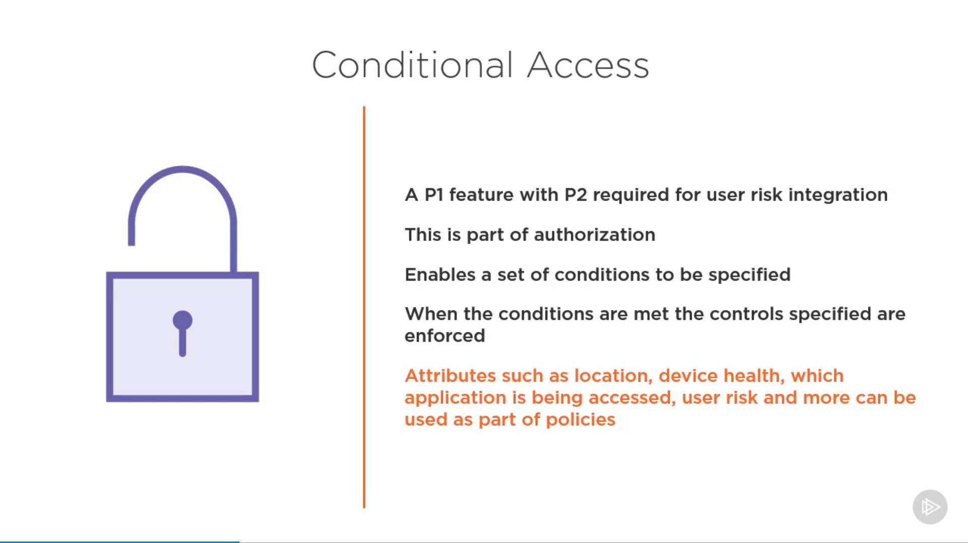

* VPN Connectivity:

<https://docs.microsoft.com/en-us/windows/security/identity-protection/vpn/vpn-conditional-access>

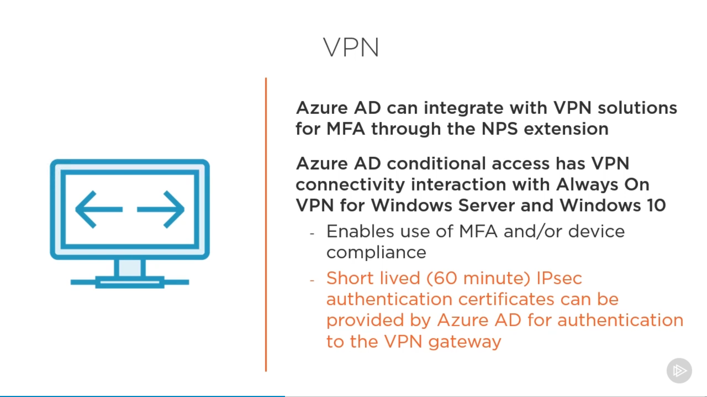

Create a certificate from “VPN Connectivity” tab and download it. And add it as trusted root certificate in NPS solution.

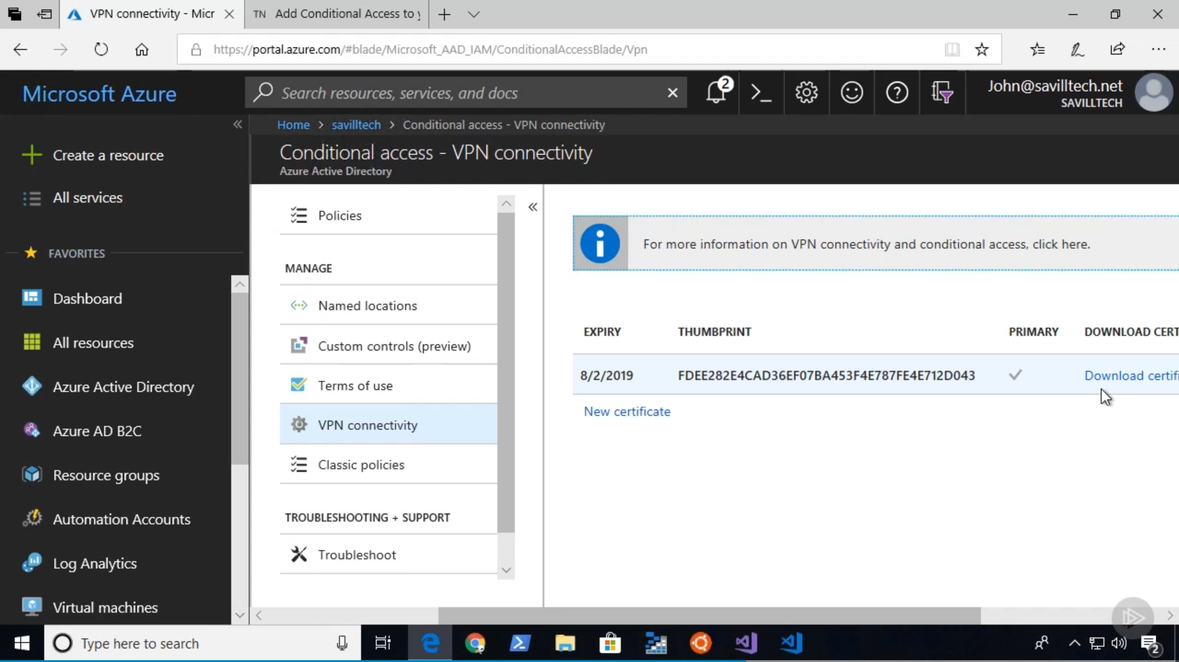

Now go to policy tab and a policy to grant conditional access to “VPN Server”.

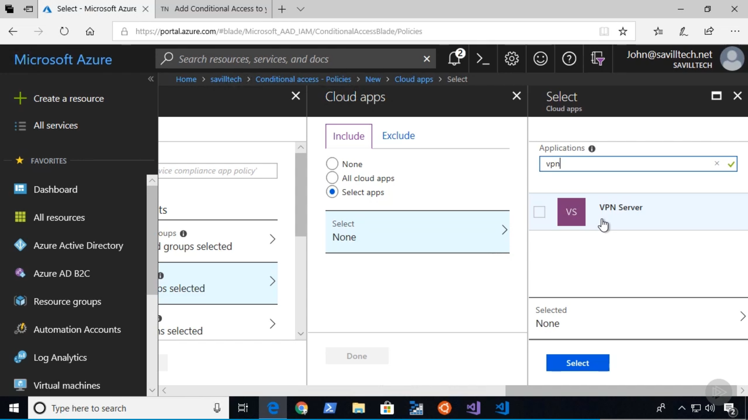

### Identity Protection

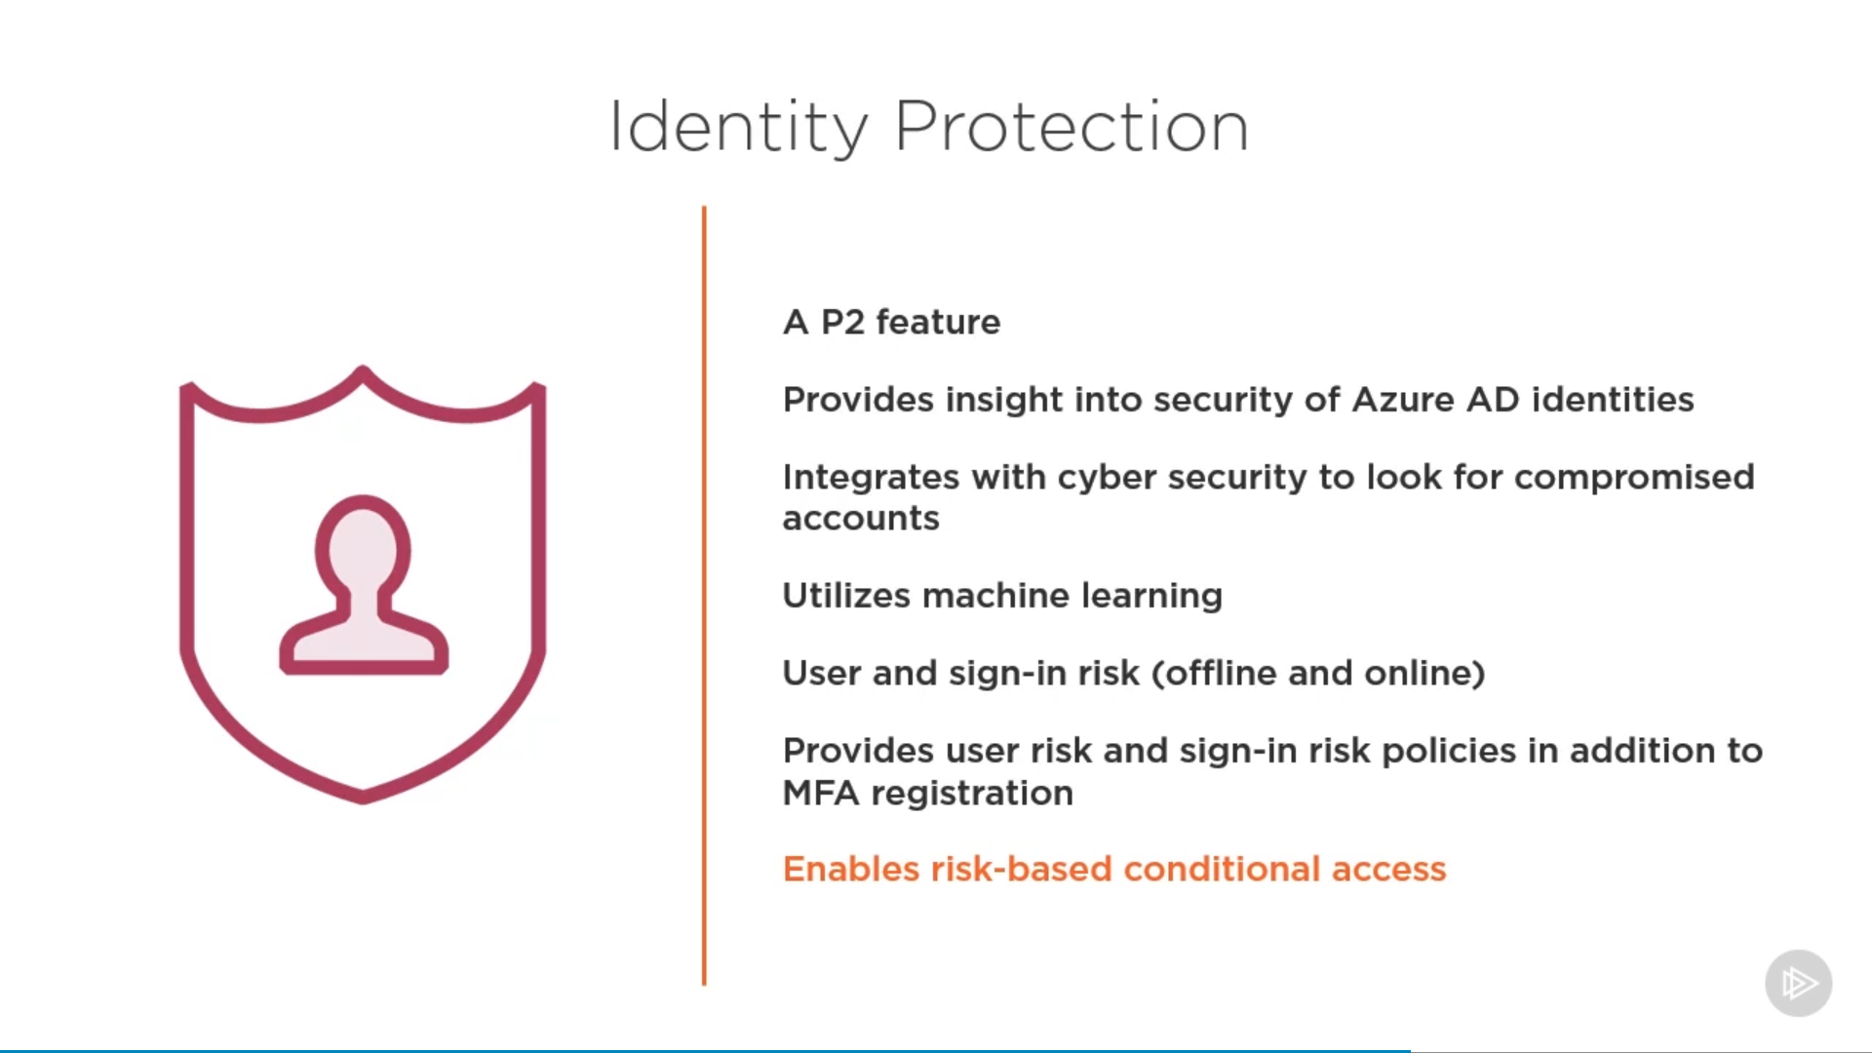

### Security Centre

## Application Proxy for Remote Authentication

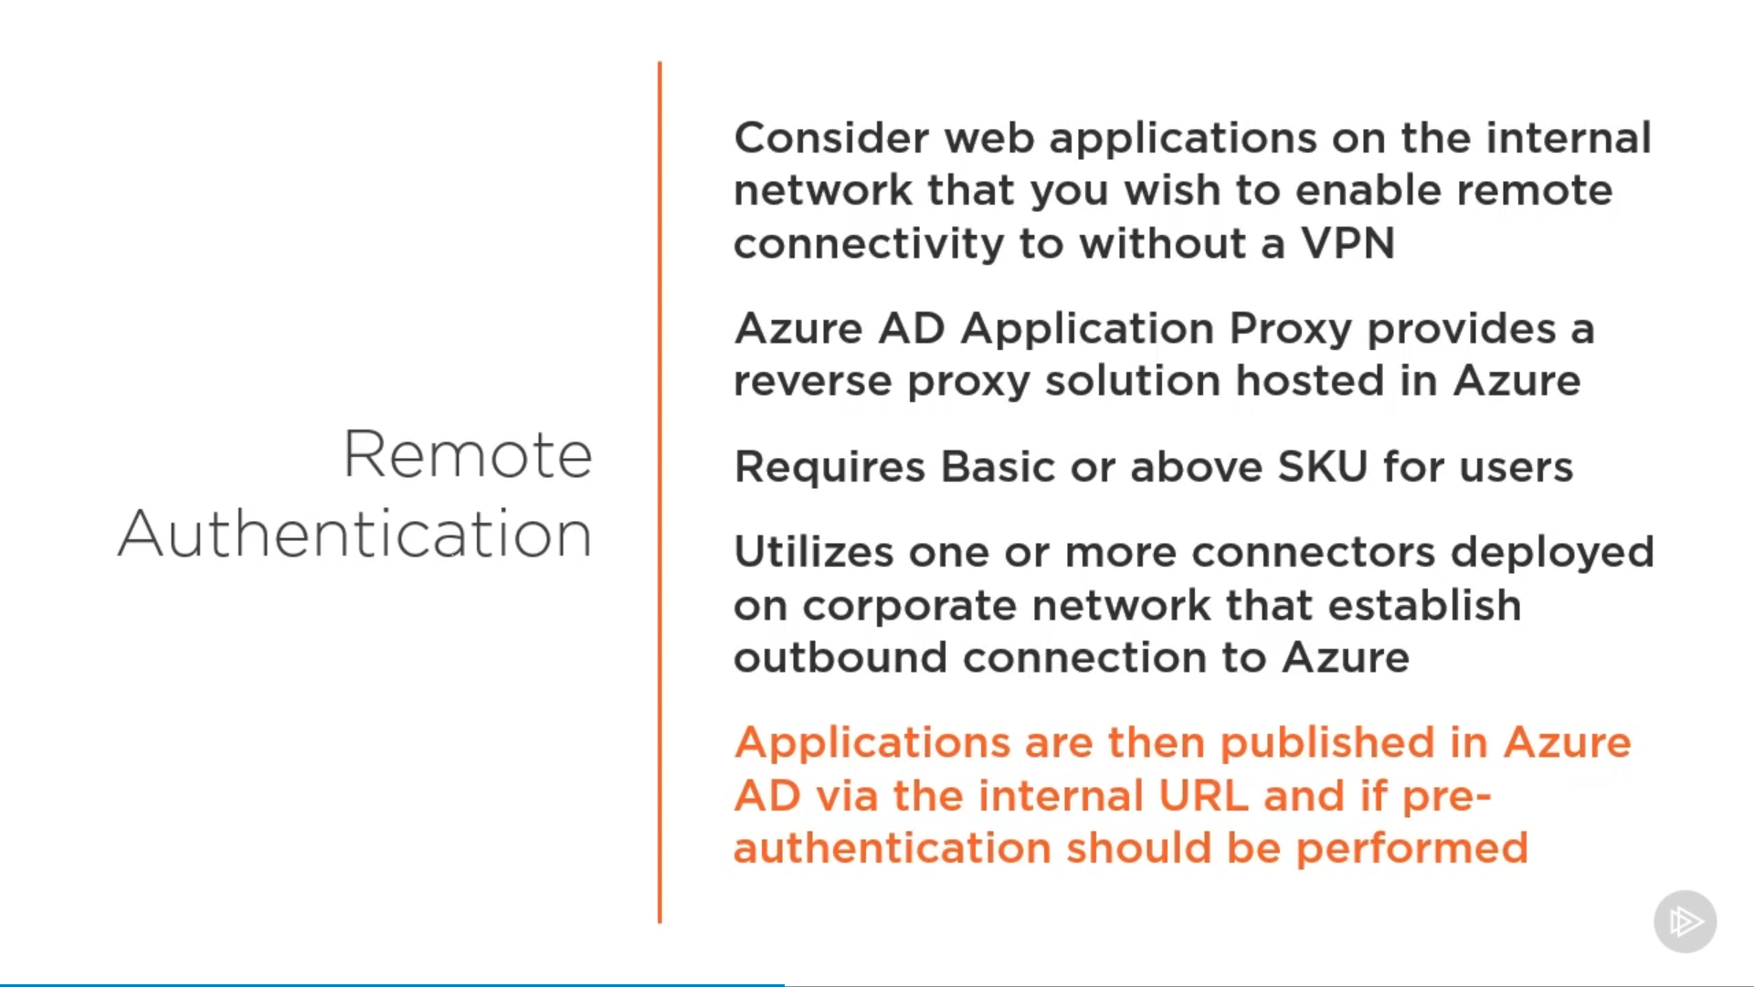

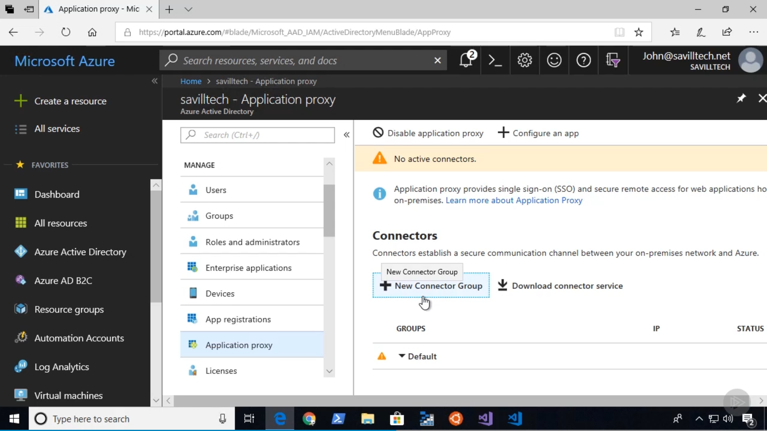

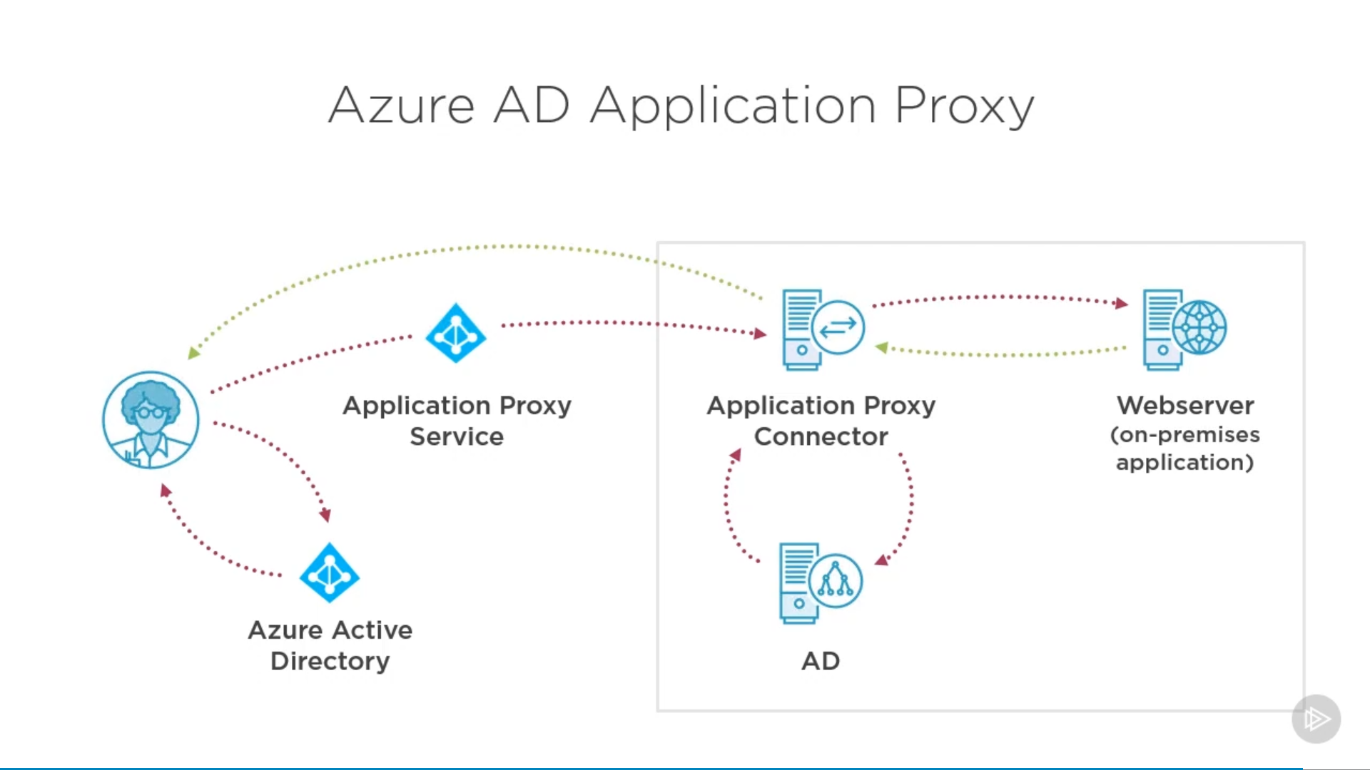

# Design authorization

* choose an authorization approach
* recommend a hierarchical structure that includes management groups, subscriptions and resource groups
* recommend an access management solution including RBAC policies, access reviews, role assignments, physical access, Privileged Identity Management (PIM), Azure AD Identity Protection, Just In Time (JIT) access

## AD Groups

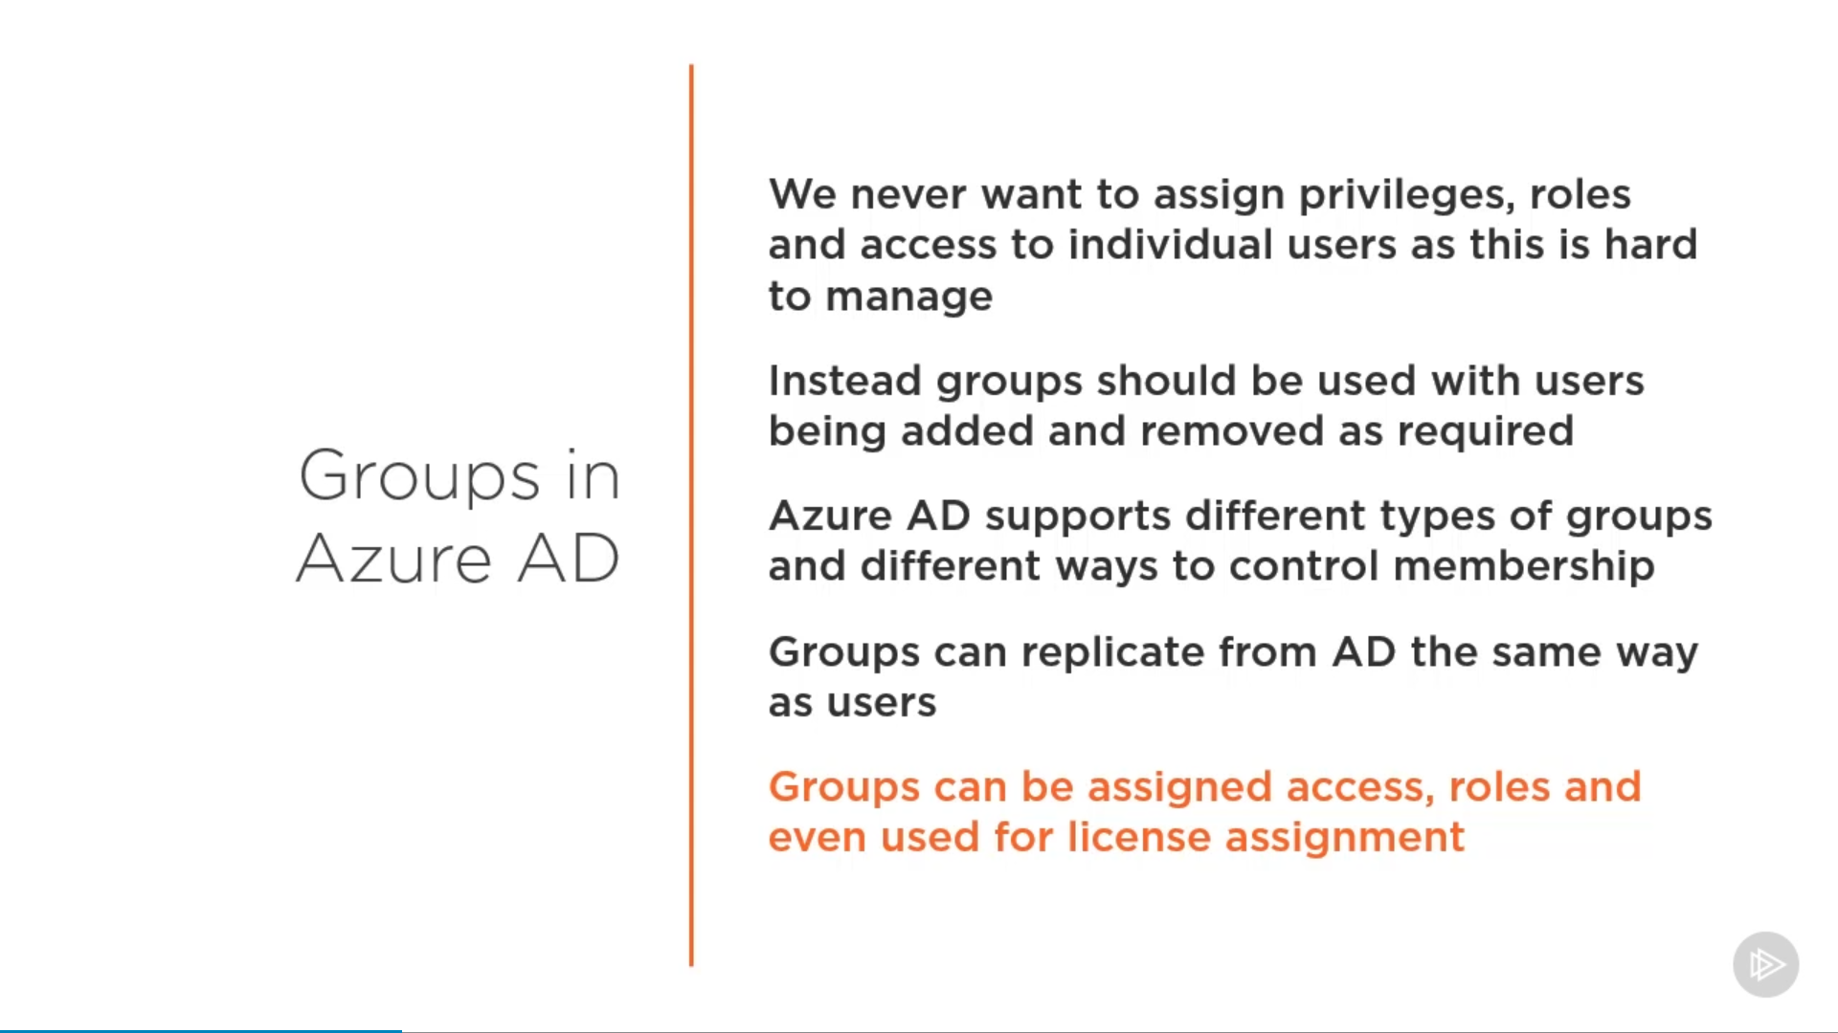

### Group Types

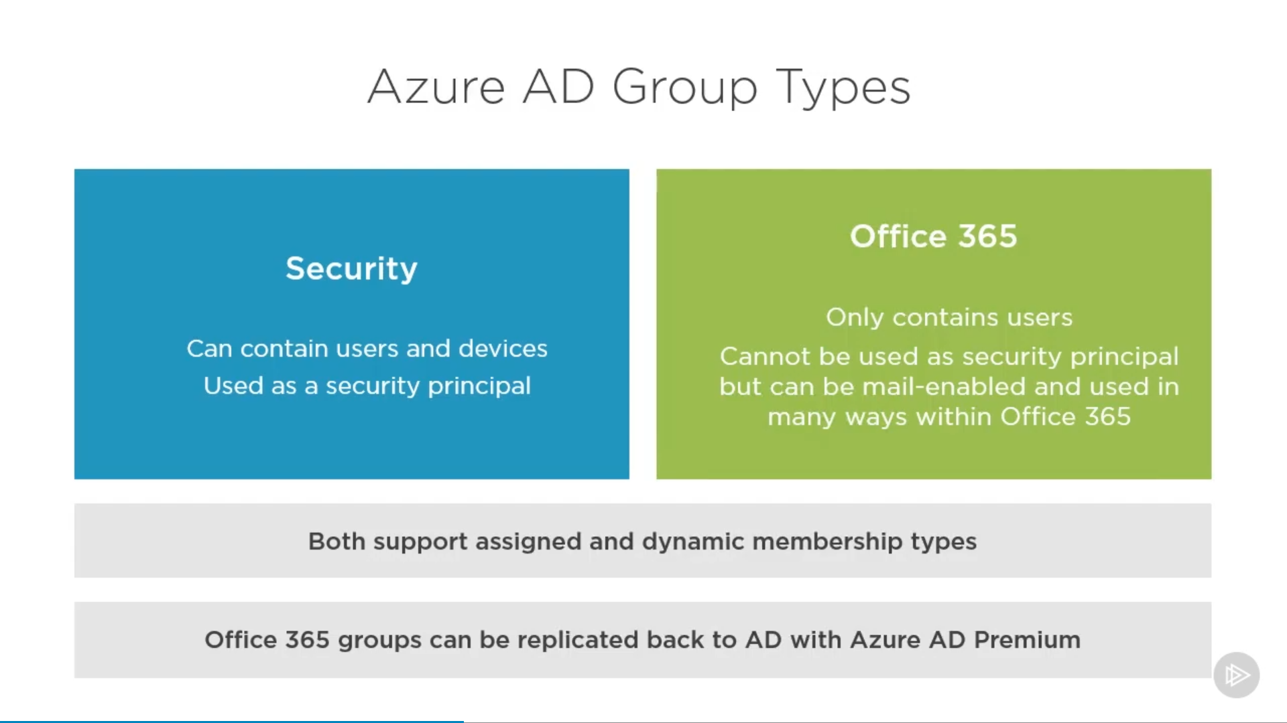

### Membership Type

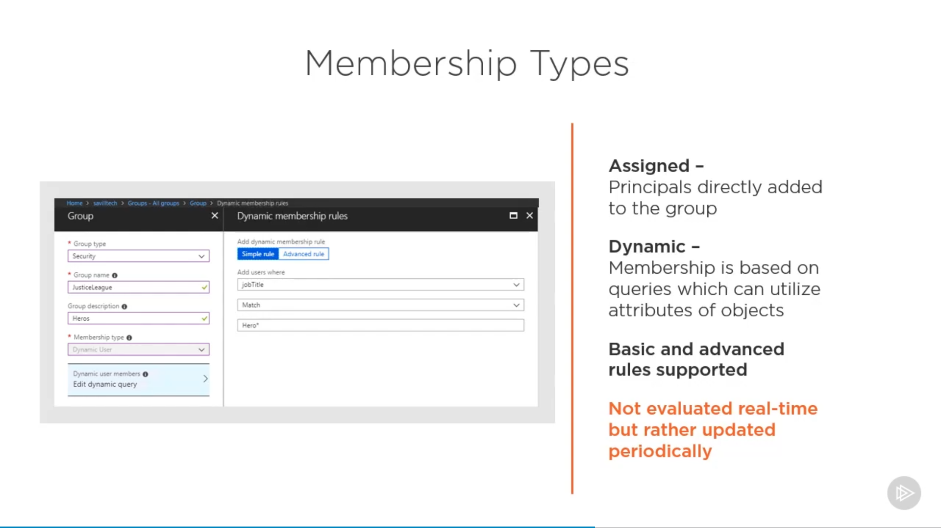

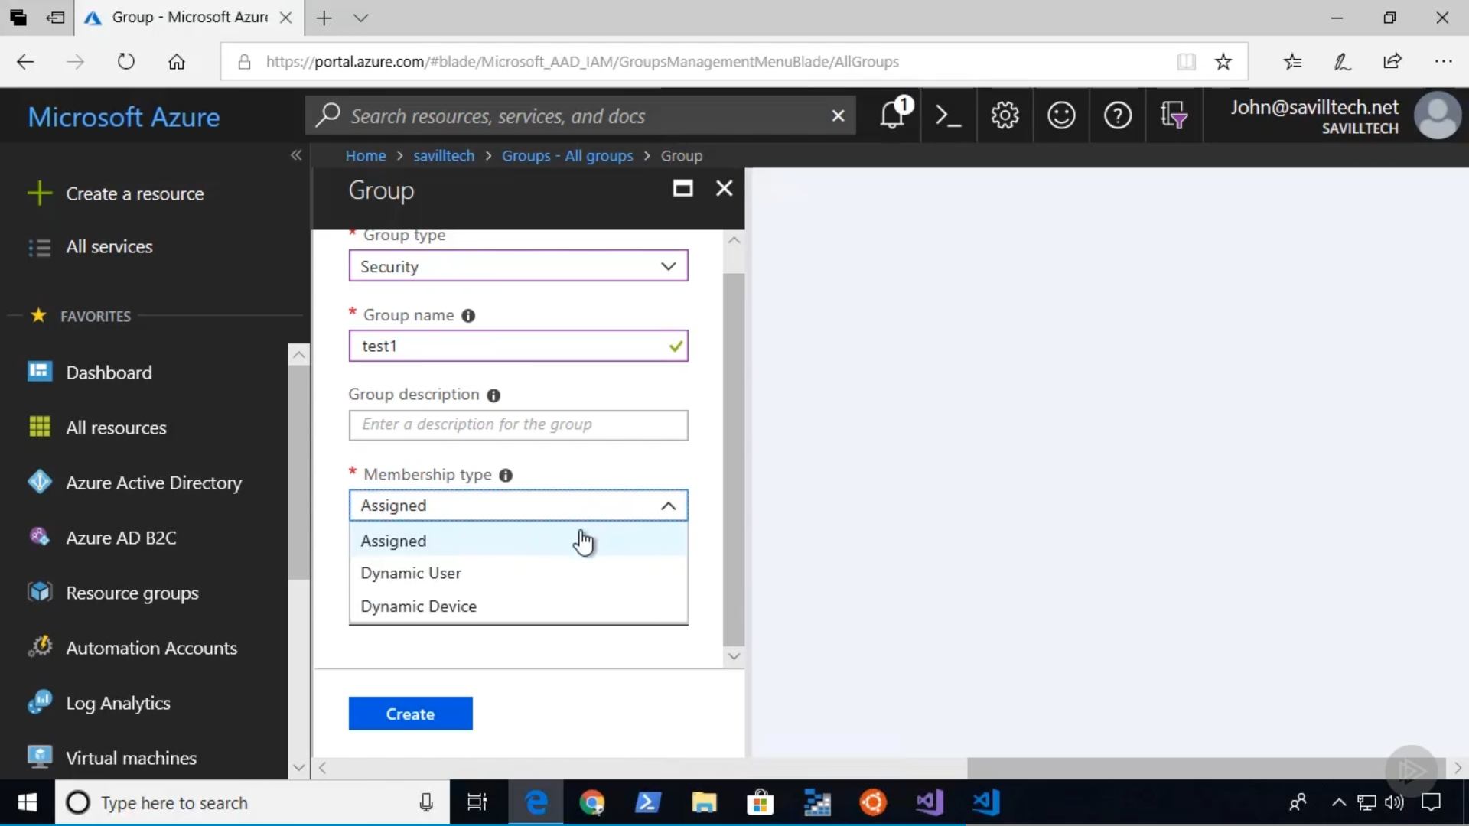

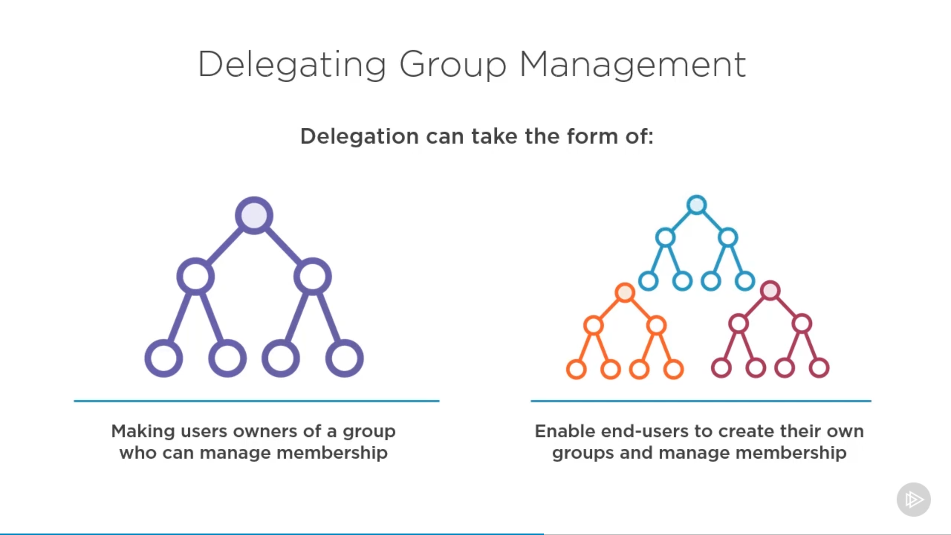

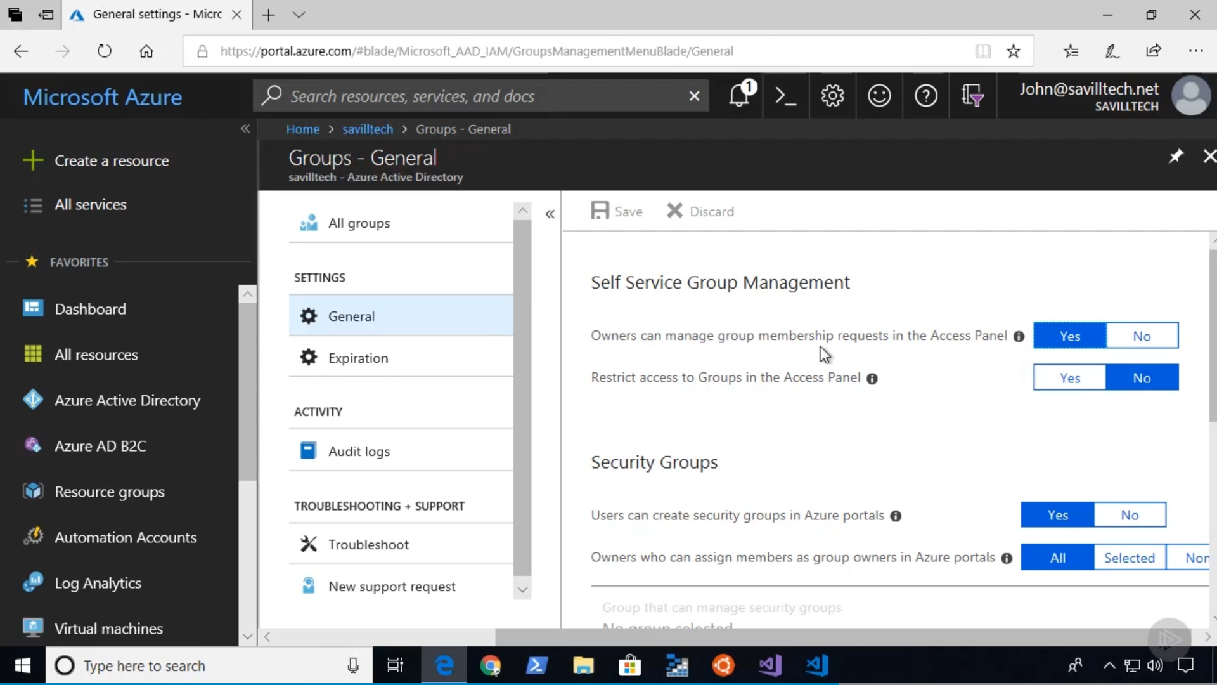

## My Account

<https://myaccount.microsoft.com>

### My Apps

<https://docs.microsoft.com/en-us/azure/active-directory/user-help/my-apps-portal-end-user-access>

<https://myapps.microsoft.com/>

<https://myapplications.microsoft.com/>

### My Work Account

<http://myworkaccount.microsoft.com/>

## Password Reset

<https://passwordreset.microsoftonline.com/>

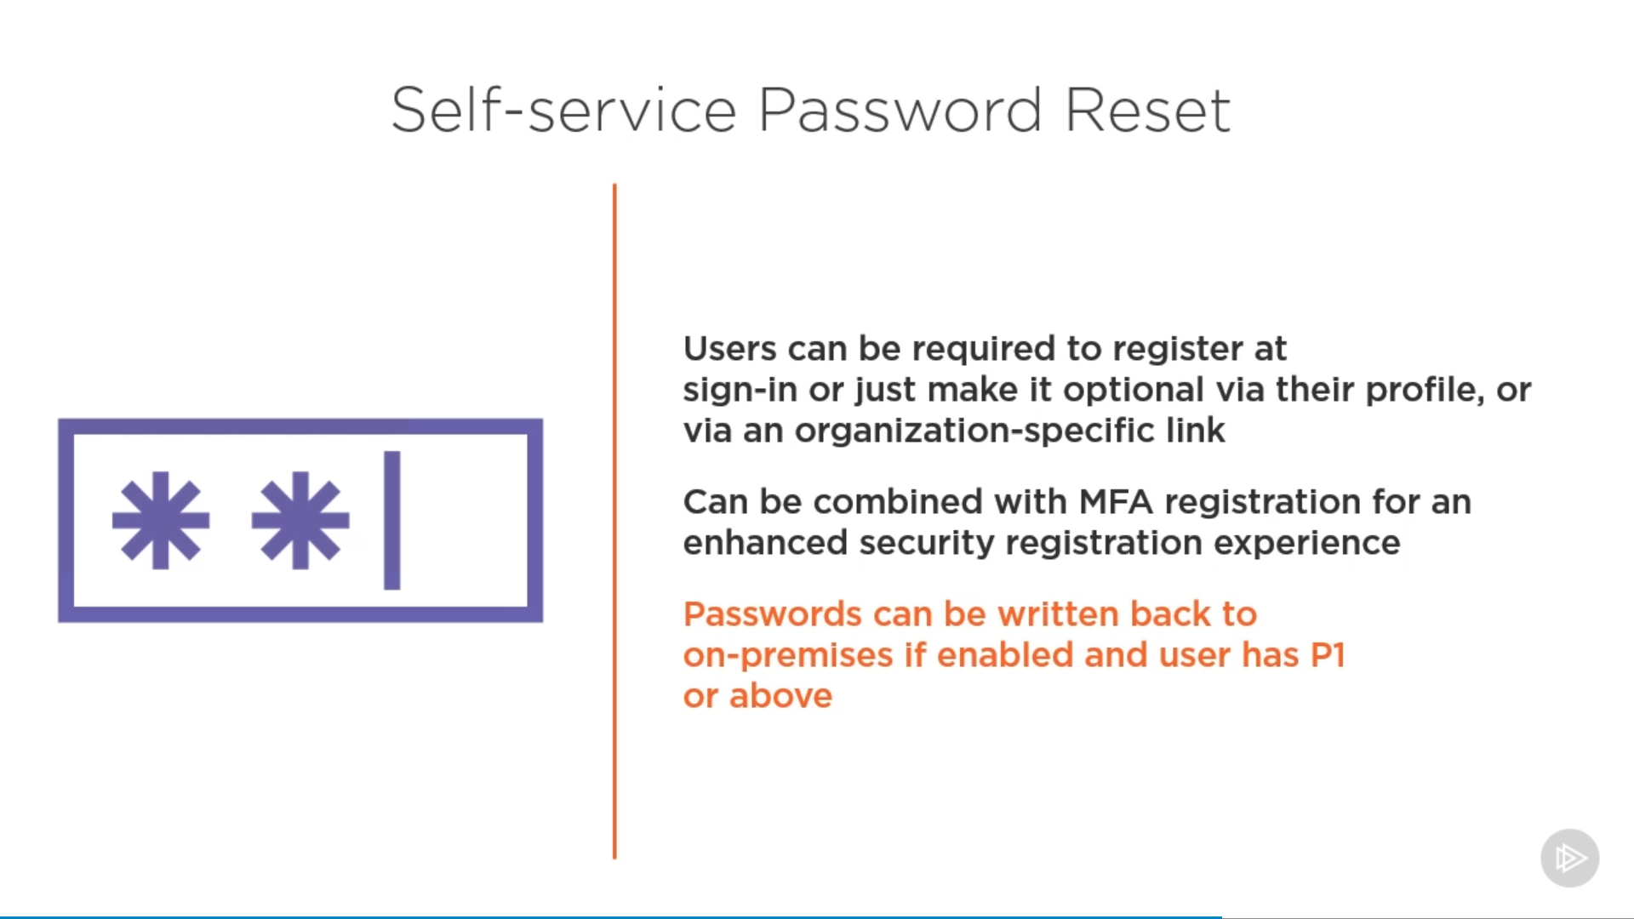

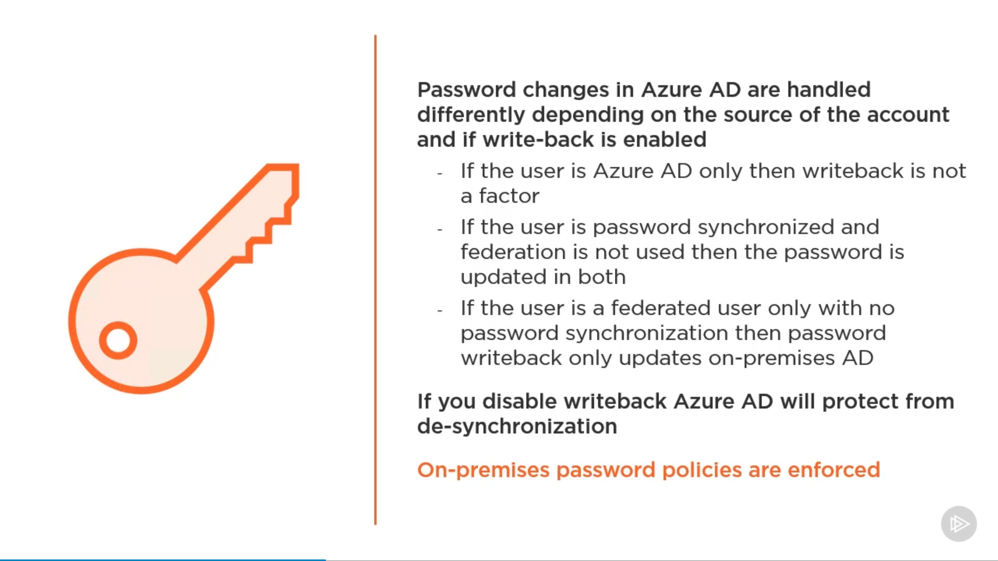

### SSPR

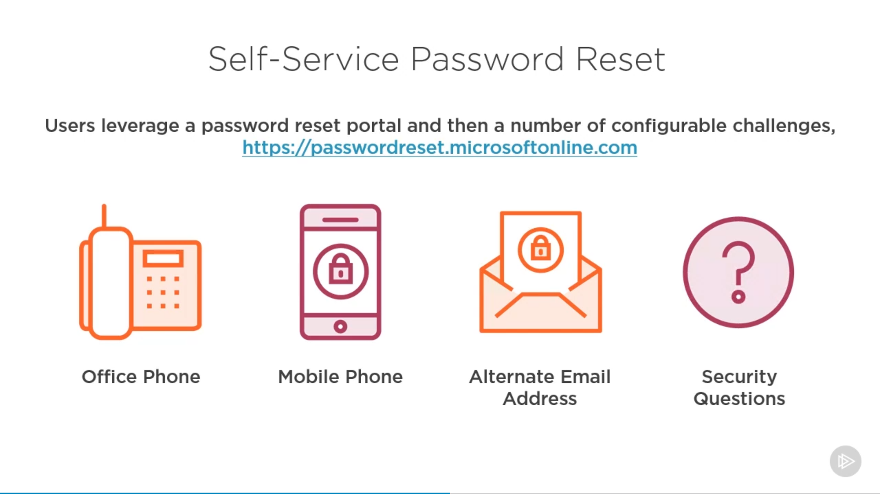

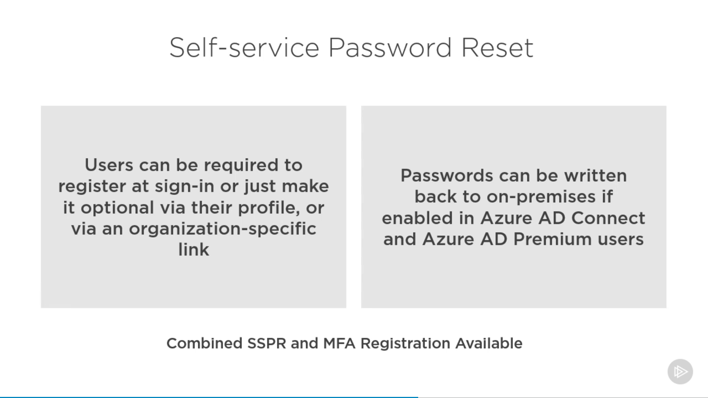

### Combined SSPR & MFA

### Stop Weak passwords

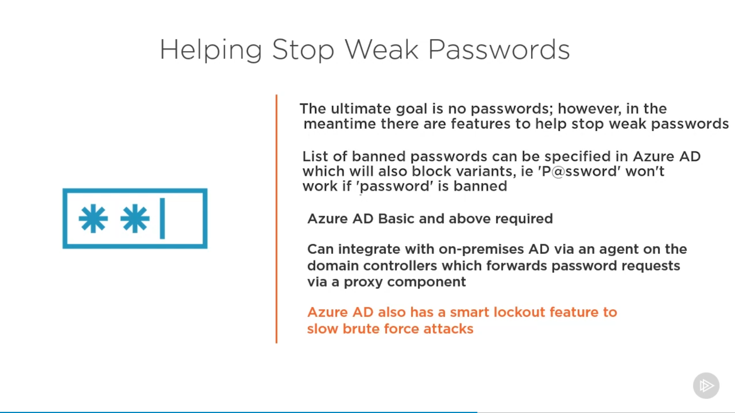

## MFA

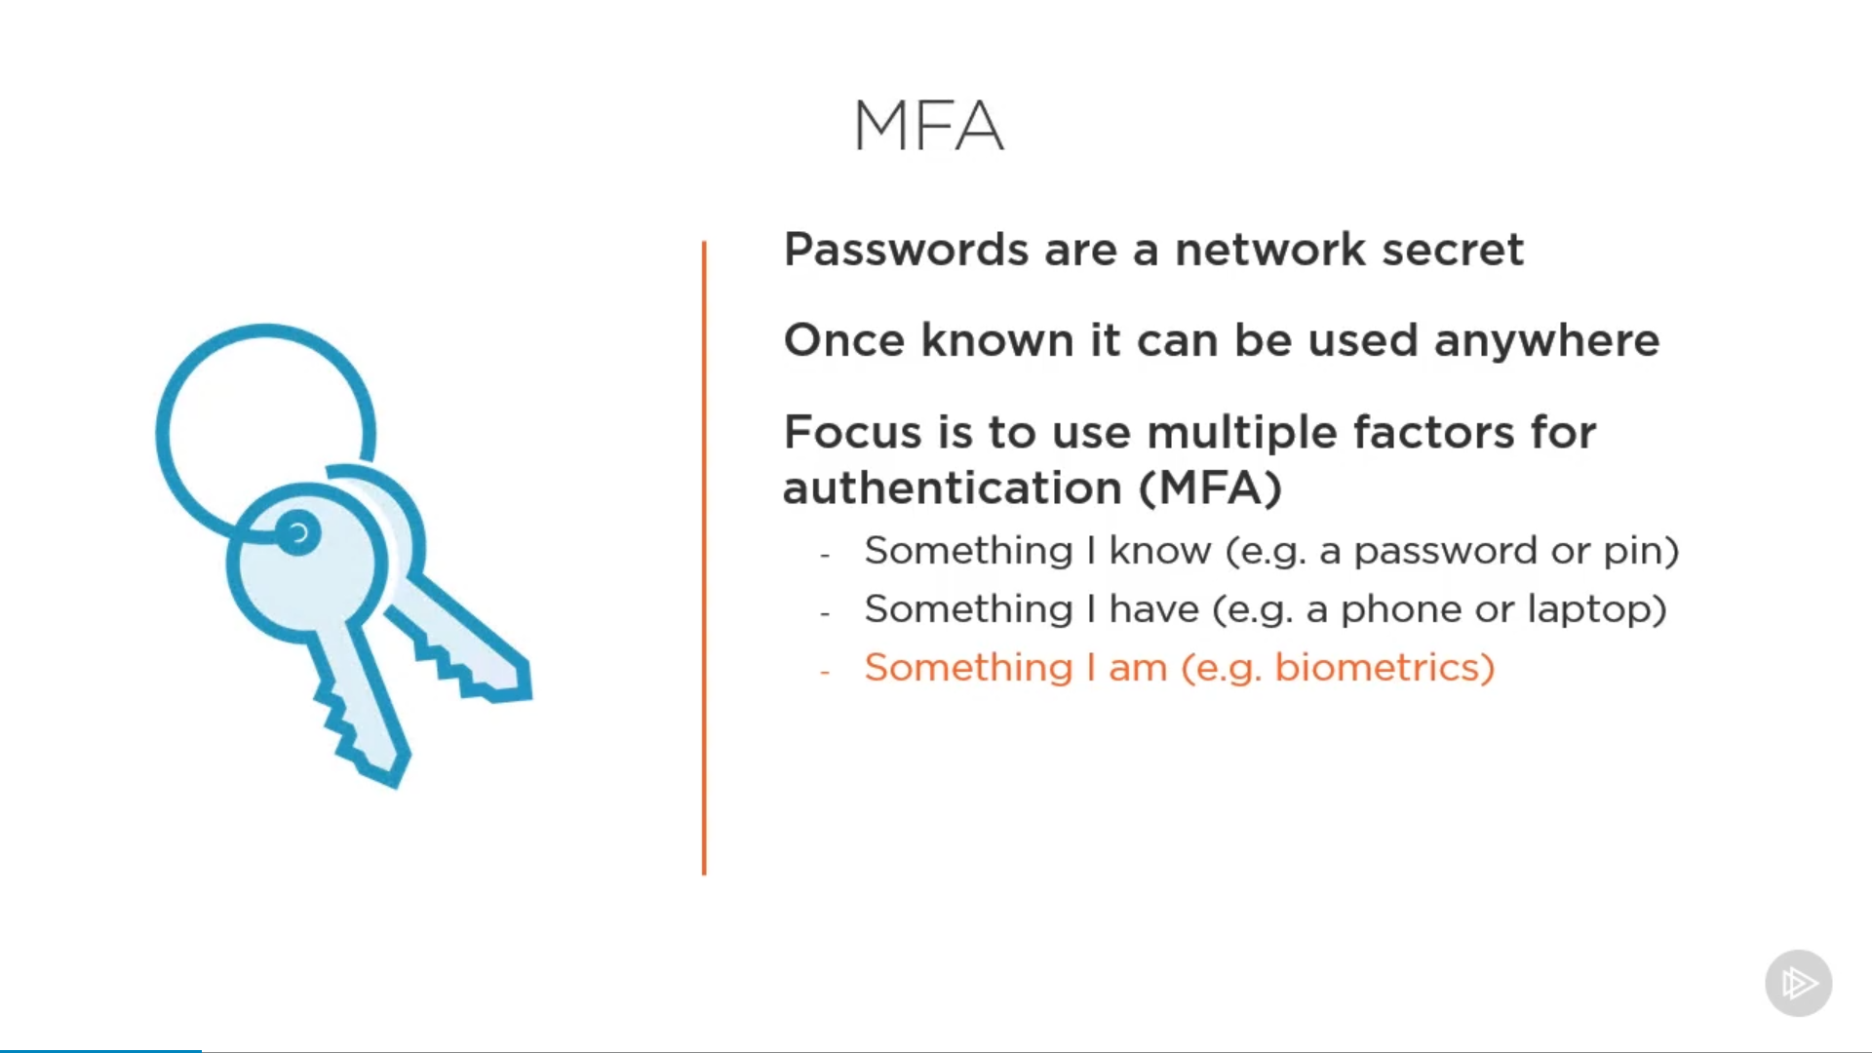

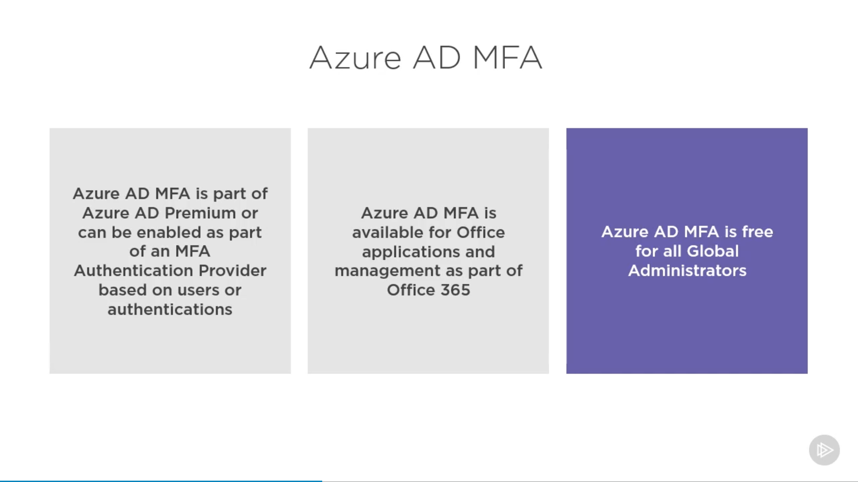

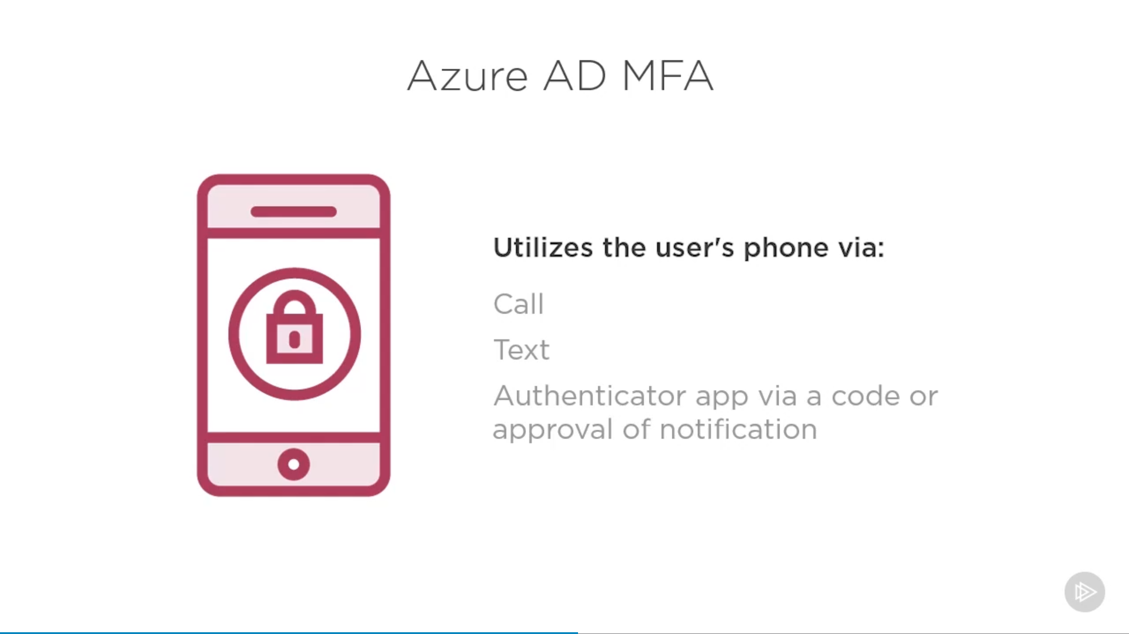

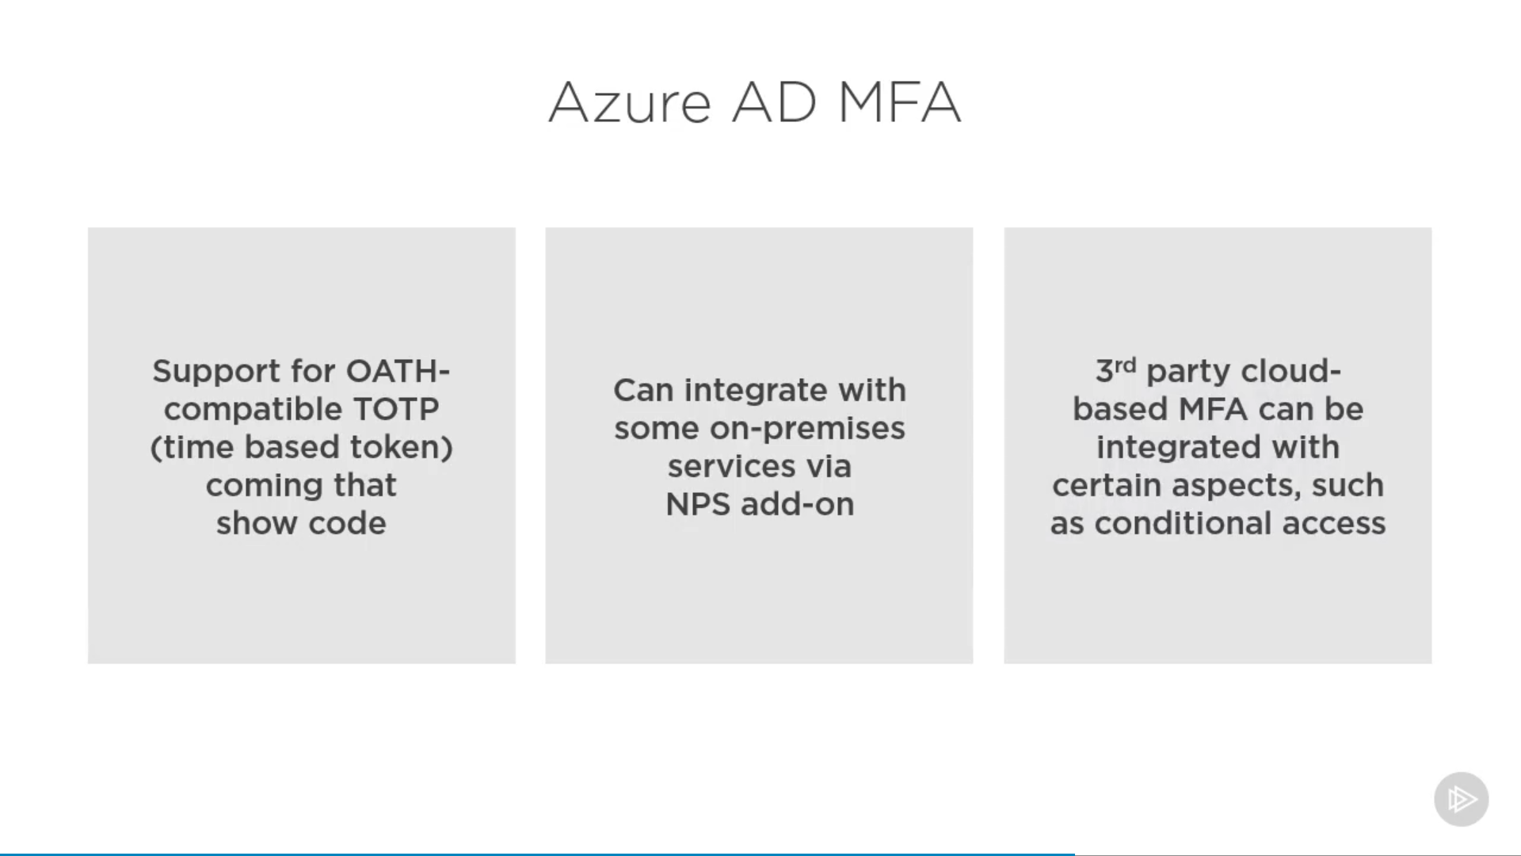

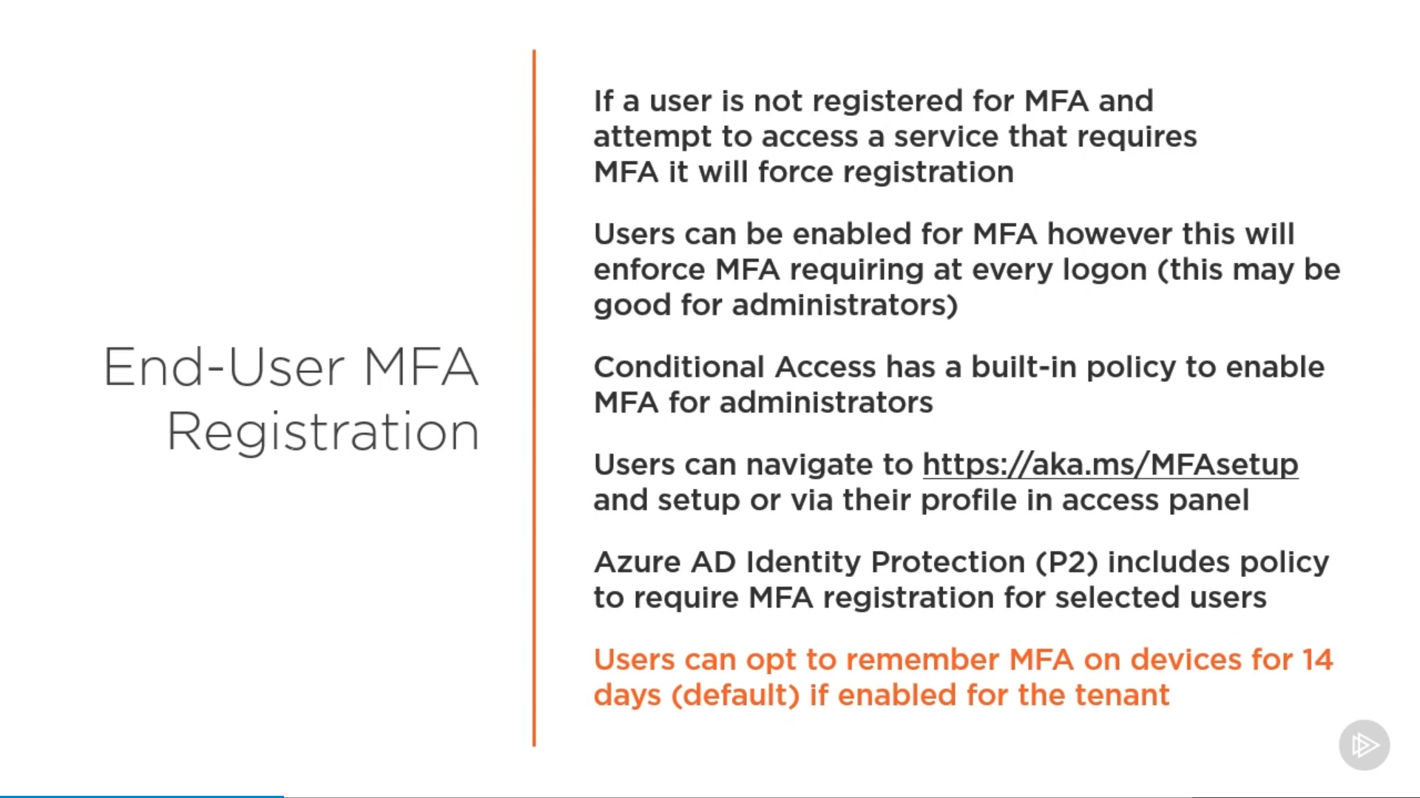

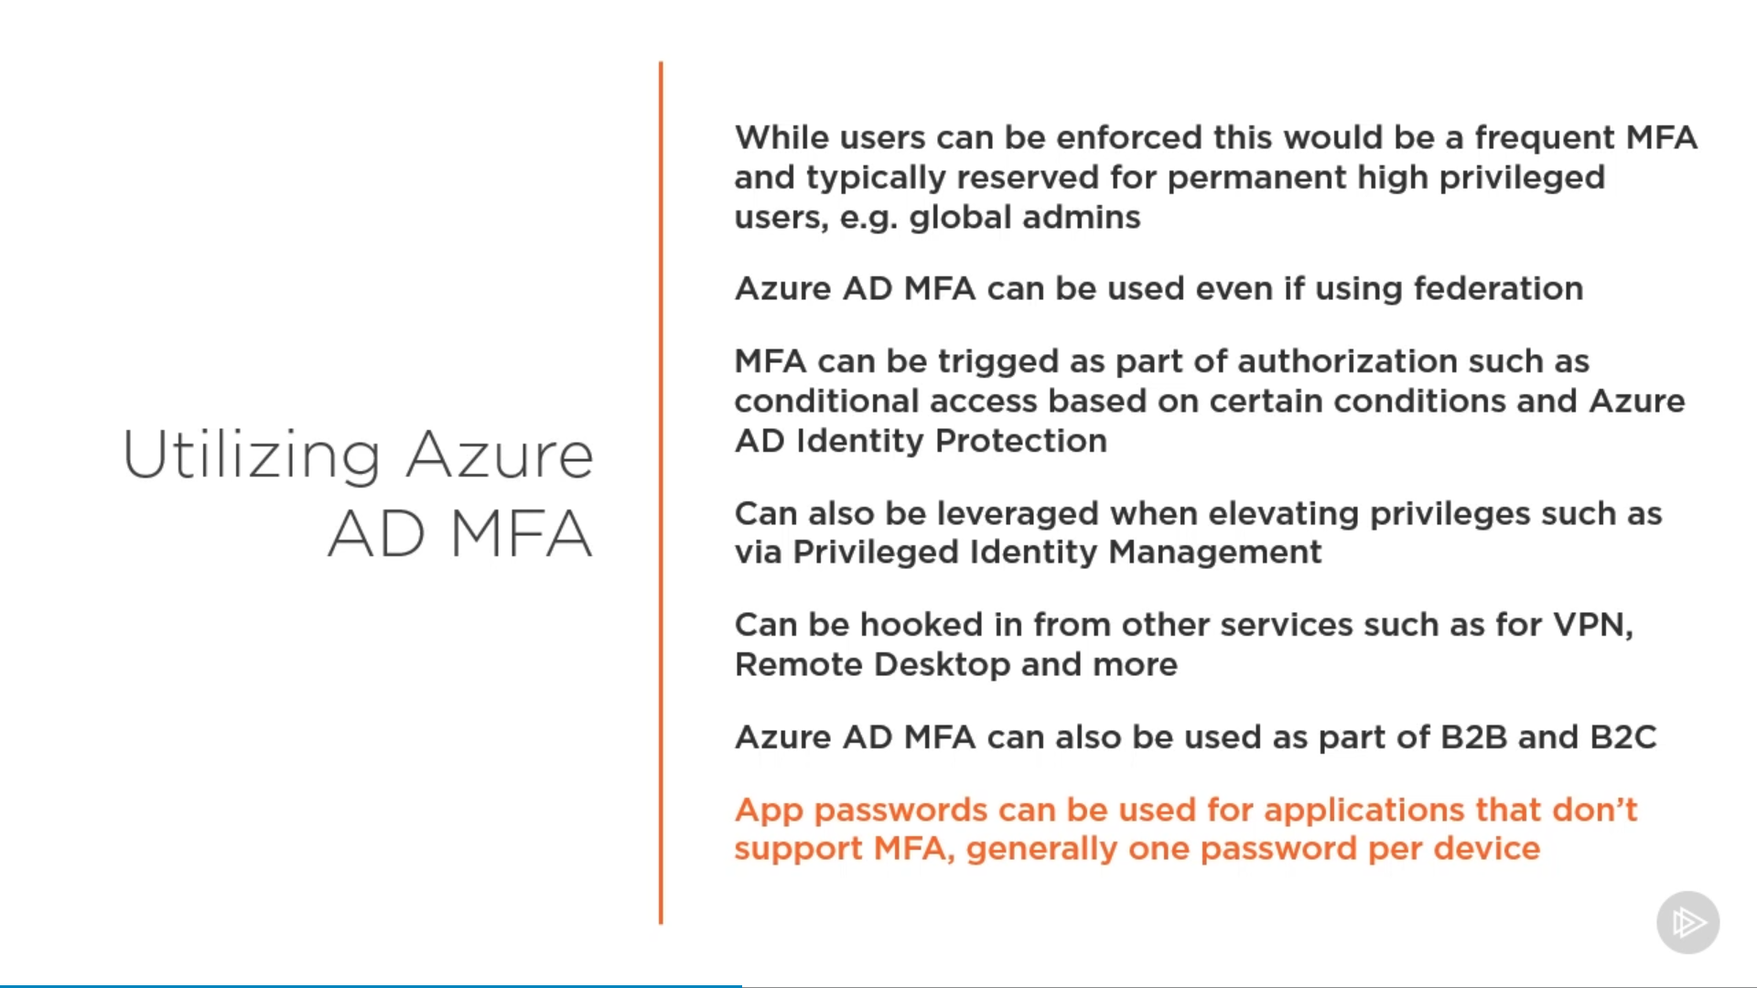

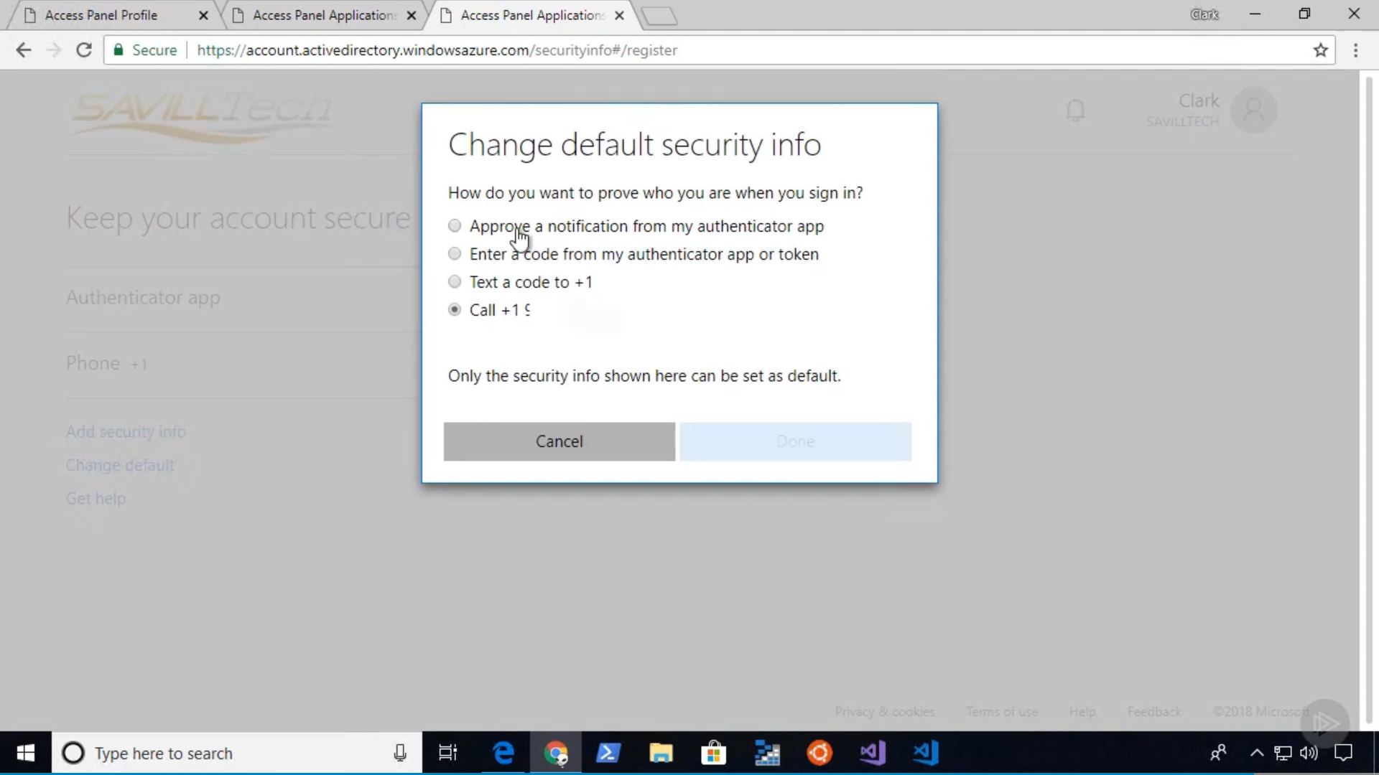

## Entitle Management

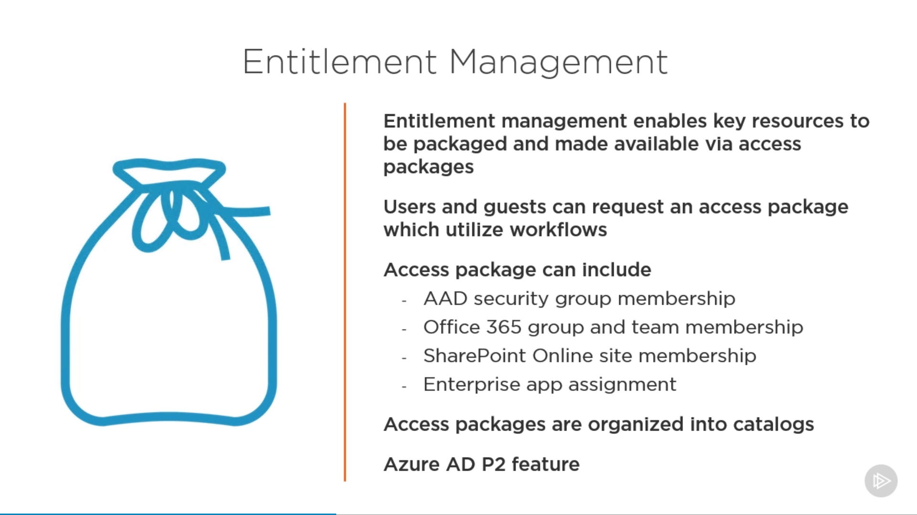

# Design governance

* recommend a strategy for tagging
* recommend a solution for using Azure Policy
* recommend a solution for using Azure Blueprint

## Governance Aspects

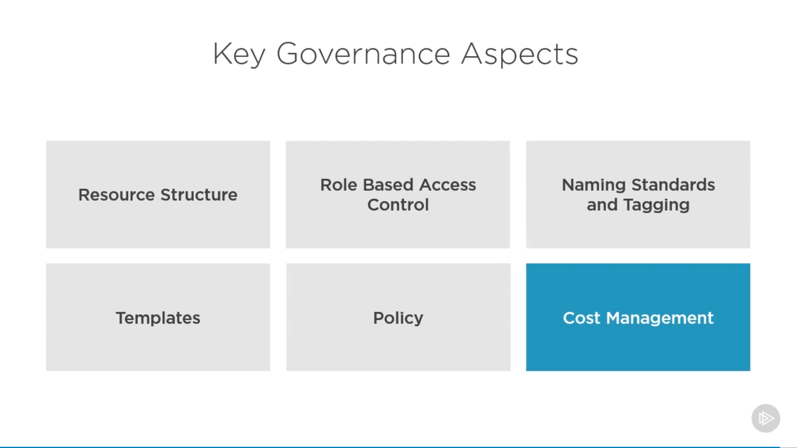

### Resource Structure

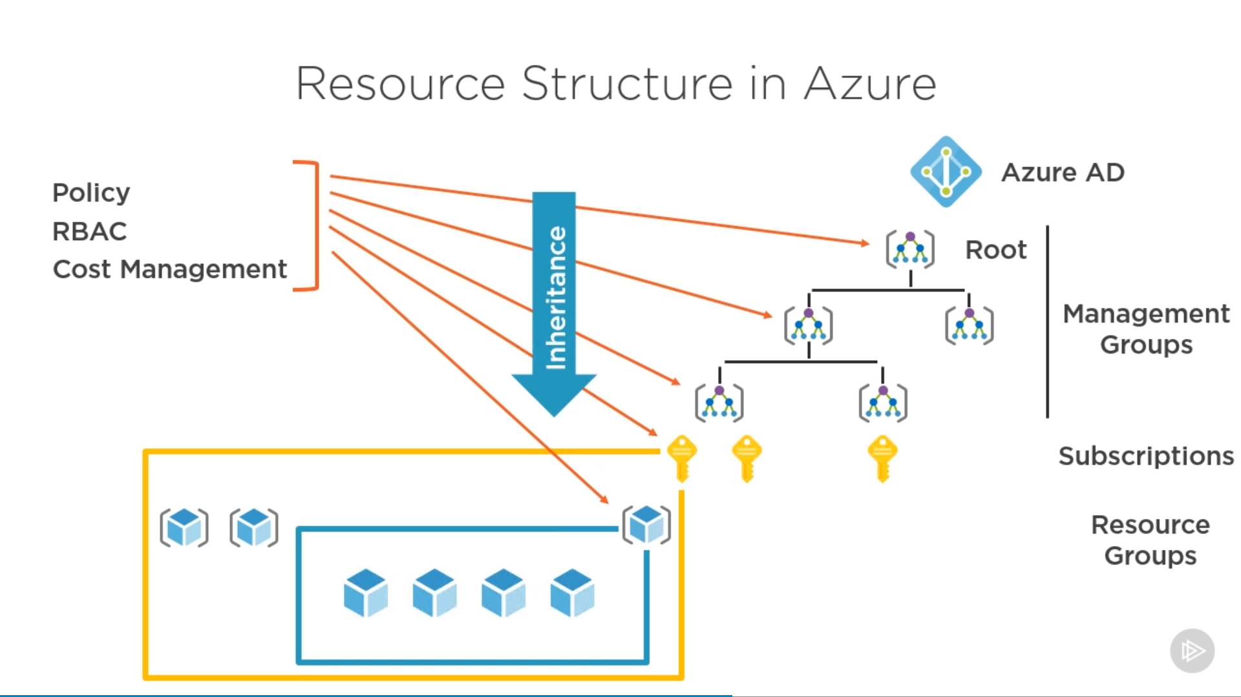

### RBAC

### Naming Standards & Tagging

<https://docs.microsoft.com/en-us/azure/cloud-adoption-framework/ready/azure-best-practices/naming-and-tagging>

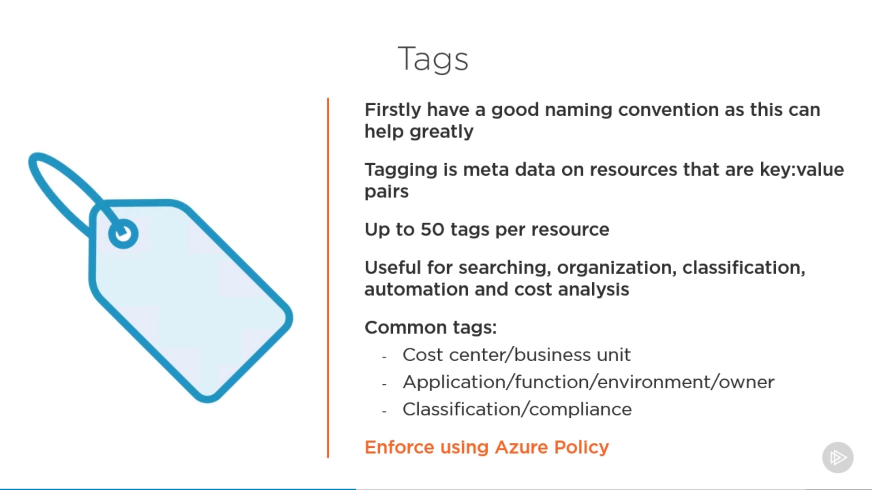

**Tags are not inherited but can be copied from parent to child via policy**

### Templates

### Policy

<https://docs.microsoft.com/en-us/azure/governance/policy/concepts/effects>

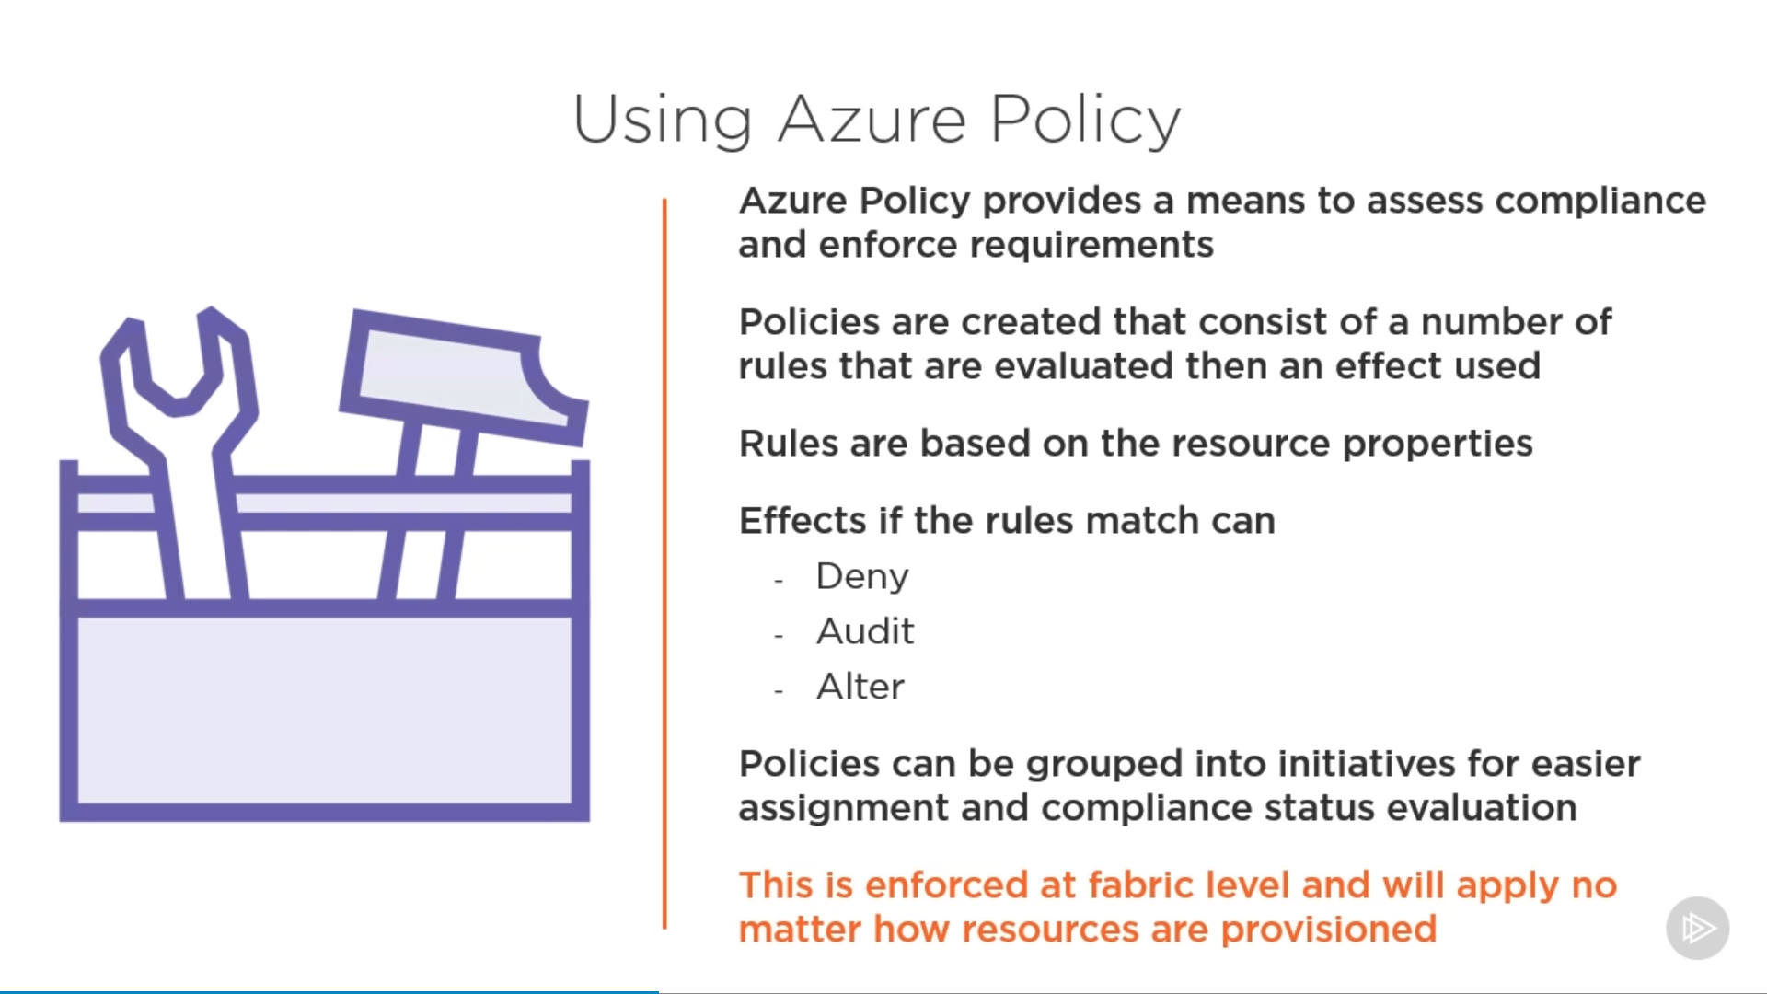

After creating a policy, it will mark all the existing resource which doesn’t meet the criteria as “**Non-compliant**” but will not change its behaviour.

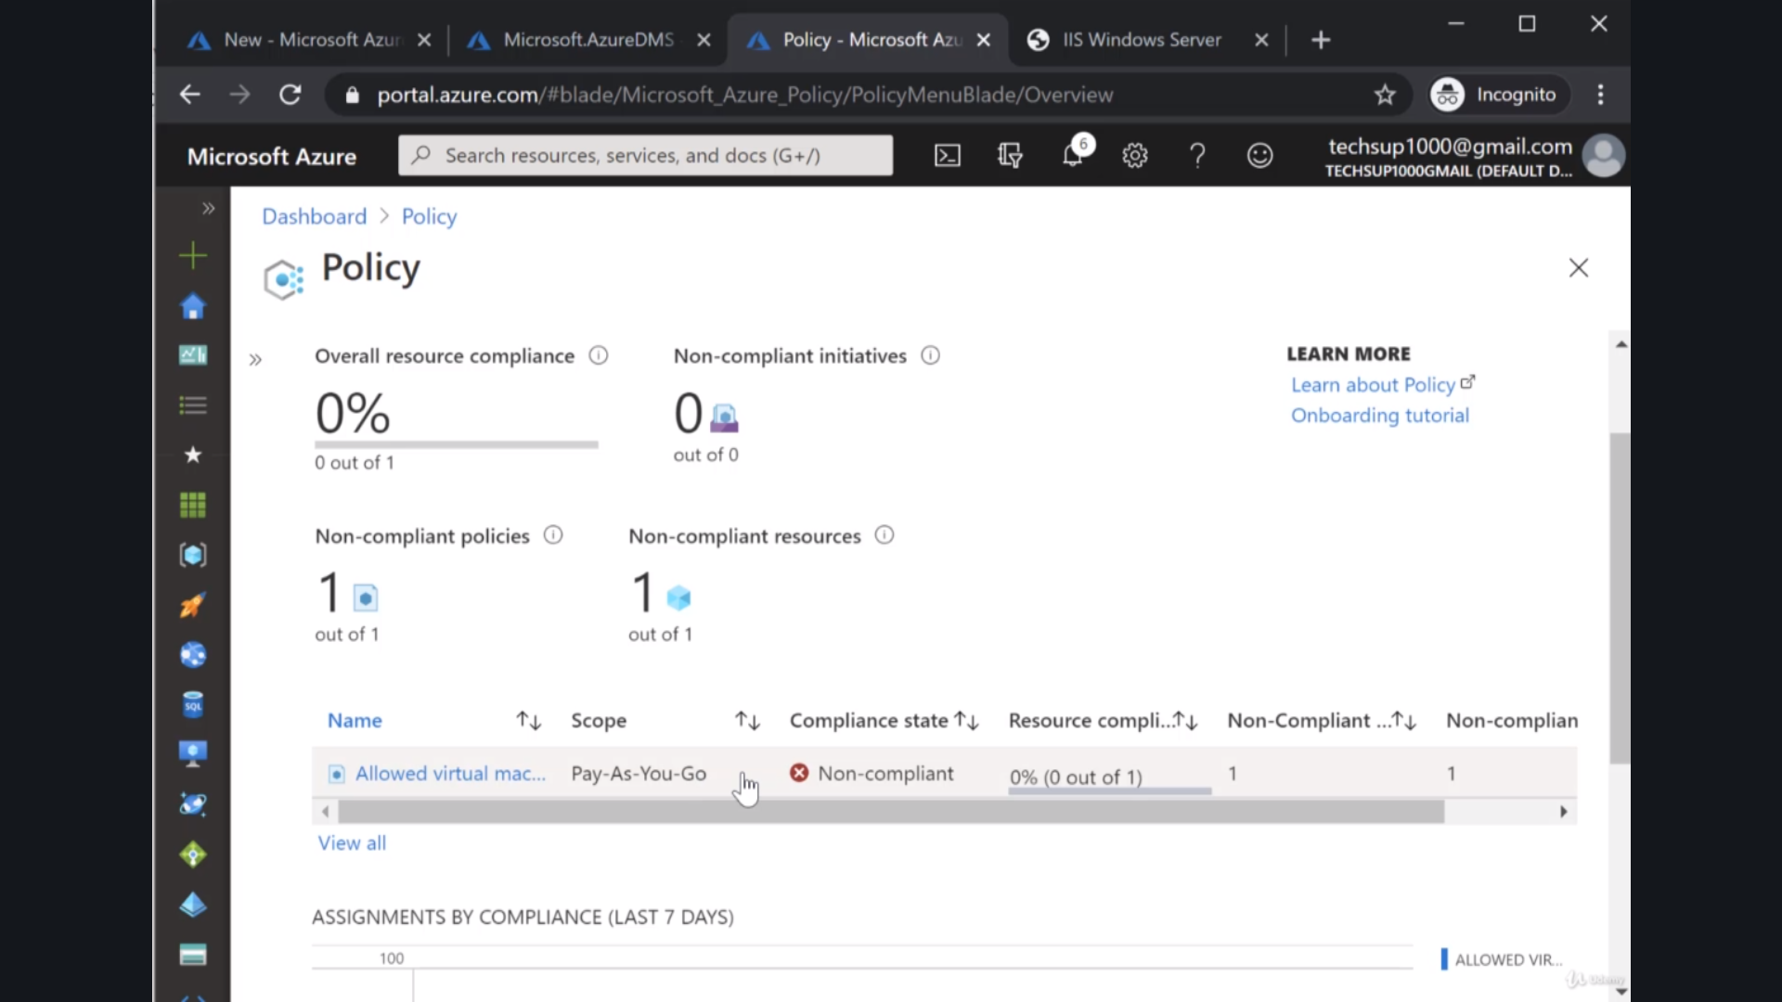

But at same time it will not allow any new resource to be created which is in violation of the said policy.

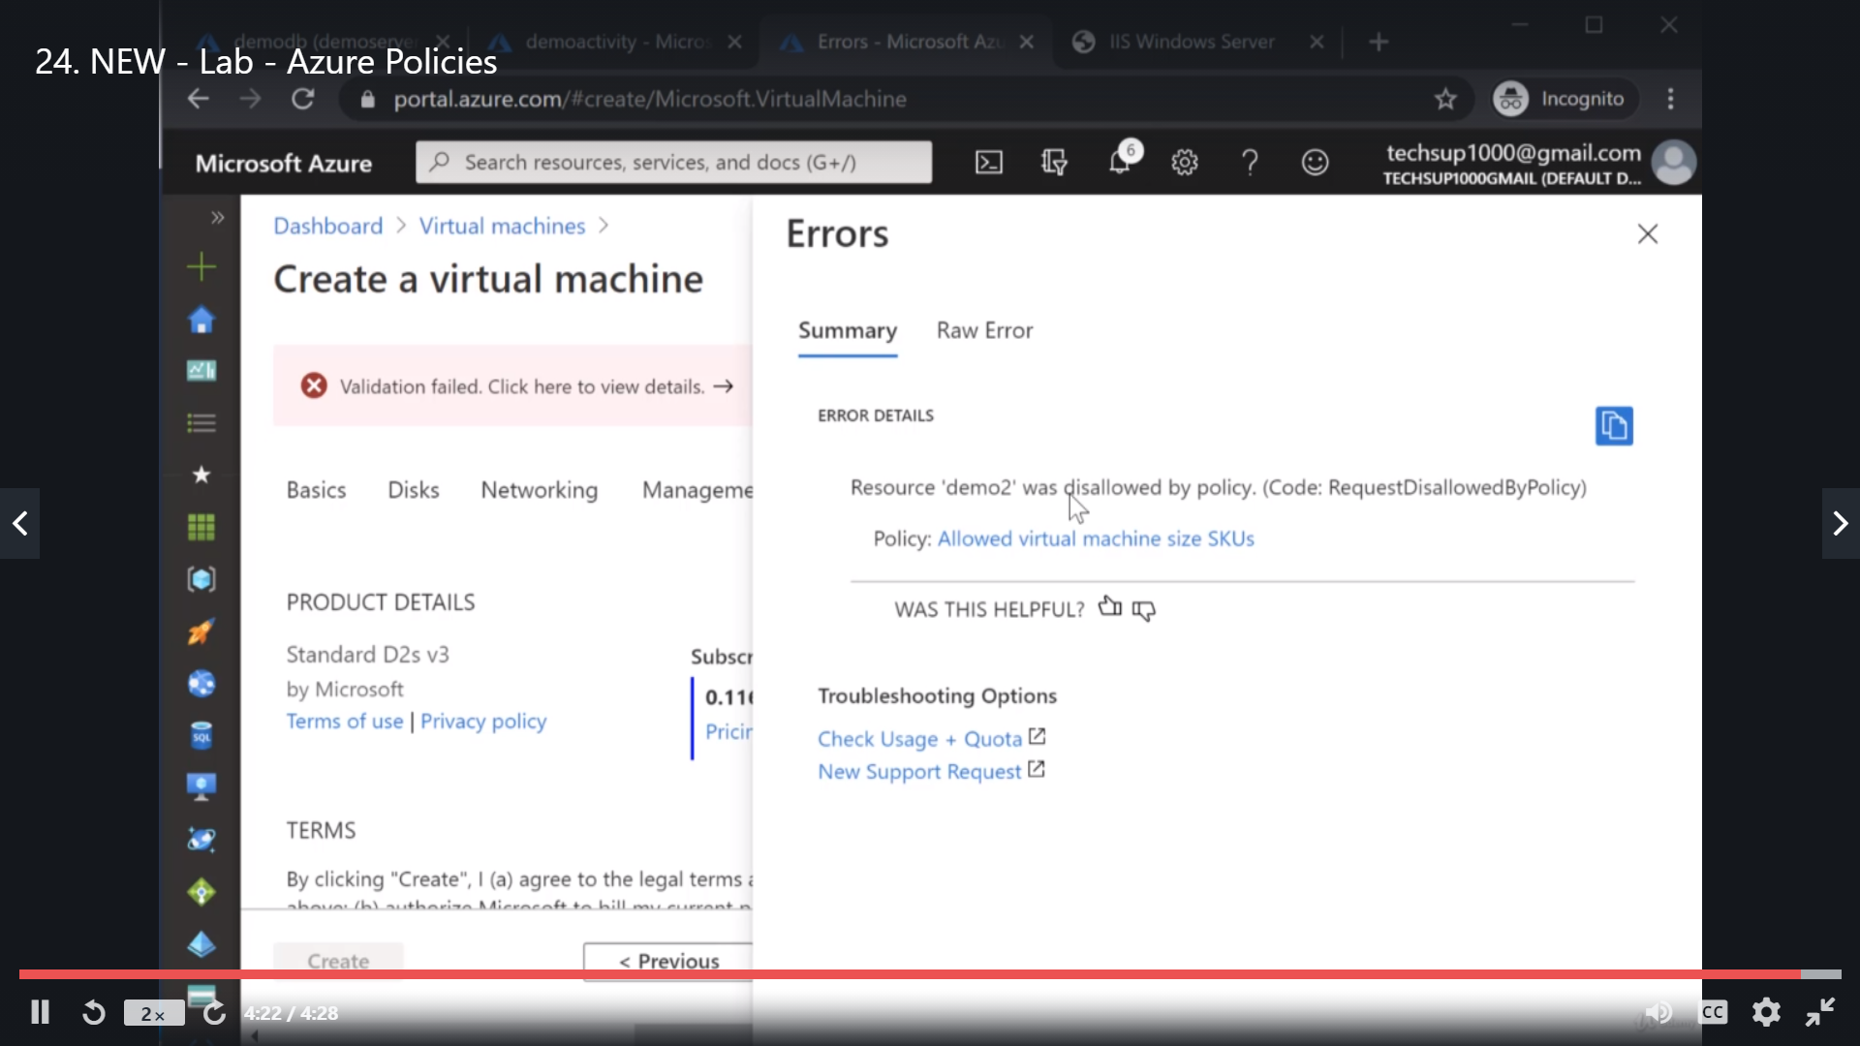

### Cost Management

# Design security for applications

* recommend a solution that includes KeyVault
  + What can be stored in KeyVault
  + KeyVault operations
  + KeyVault regions
* recommend a solution that includes Azure AD Managed Identities
* recommend a solution for integrating applications into Azure AD

## Azure AD MASL

<https://azure.microsoft.com/en-in/blog/start-writing-applications-today-with-the-new-microsoft-authentication-sdks/>

For all intents and purposes, **MSAL** can be considered **ADAL** vNext. Additionally, with **MSAL** you can also get authentications for **Azure AD B2C**.

<https://docs.microsoft.com/en-us/azure/active-directory/develop/msal-overview>

<https://docs.microsoft.com/en-us/azure/active-directory/develop/msal-authentication-flows>

Note: Check all the option of web app authentication section of the blade